PAUL ROLLAND | NIGHT WATCHMAN | NIGHT WATCHMAN MINISTRIES
May 10 2024
PDF ‘TEXT ONLY’ VERSION: THE BEAST AND THE WORLD HEALTH ORGANIZATION (WHO)
https://youtu.be/aG0pyaBuSaY
https://youtu.be/bmvcxdlfhts

Revelation 13:7 And it (7) ‘was GIVEN unto him’ to make war (7) with the saints, and to overcome them: and (7) ‘POWER WAS GIVEN HIM’ (PRINCE-BEAST-ANTICHRIST) (7) OVER ALL KINDREDS, AND TONGUES, AND NATIONS. (7777)
Revelation 13:2 And (7) THE BEAST which I saw was like (7) unto a LEOPARD, and his feet were (7) as the feet of a BEAR, and (7) his mouth as the mouth of a (7) LION: and THE (5) DRAGON ‘GAVE HIM’ HIS (7) POWER, AND (5) HIS SEAT, AND GREAT AUTHORITY.
(777777) 6x7. Six (‘6’) is God’s Divine Number denoting evil man or man’kind. In this case, God is referring to the Evil Prince, Beast, Antichrist. Seven (‘7’) is God’s Divine Number denoting His ‘TRUTH OR TRUTHFULNESS.’
THE ANTICHRIST; ‘A KING OF DARK SENTENCES’ (POLITICAL LANGUAGE, FALSE AGREEMENTS, DECEIVING COVENANTS, LIES, BACK-ROOM DEALING, DECEPTION, INTRIGUE, ANNOUNCEMENTS AND DECEIVING DOCTRINES AND PROGRAMS.)
23 (7) “And in the latter time of their (7) kingdom, when the transgressors are come to (7) the full, A KING OF FIERCE COUNTENANCE, (7) AND UNDERSTANDING DARK SENTENCES, SHALL STAND UP.
24 And his power shall (7) be mighty, but not by his own (7) power: and he shall destroy wonderfully, (7) and SHALL PROSPER, AND PRACTICE, and shall (7) destroy the mighty and the holy people.
25 (7) And through his policy also he SHALL (7) CAUSE CRAFT TO PROSPER IN HIS HAND; (7) and he shall magnify himself in his (7) heart, and BY PEACE SHALL DESTROY MANY: he shall also (7) stand up against the Prince of princes; (7) but he shall be broken without hand.” (Daniel 8:23-25)
(77777777777777) = 7+7 = 14 (‘sevens’)

CONTENT:
- THE WHITE HORSEMAN PRINCE BEAST ANTICHRIST MAHDI RIDES A WHITE ARABIAN STALLION
- THE HAVE BEEN PREPARING US FOR YEARS!
- HE'S ALREADY ARRIVED BUT PEOPLE DON'T SEE IT
- WORLD HEALTH ORGANIZATION IS MAKING A MASSIVE POWER GRAB—AND BIDEN IS ENABLING IT
- THE WORLD HEALTH ORGANIZATION IS CREATING A NEW ‘PANDEMIC INDUSTRY’
- ONE MONTH UNTIL WHO PANDEMIC AGREEMENT USURPS U.S. SOVEREIGNTY
- THE WORLD HEALTH ASSEMBLY IS THE DECISION-MAKING BODY OF WHO
- COLLABORATION WITH OTHER INTERGOVERNMENTAL ORGANIZATIONS
- A SUMMARY OF WHO’S ENGAGEMENT WITH THE UNITED NATIONS AND OTHER INTERGOVERNMENTAL ORGANIZATIONS
- ONE BILLION MORE PEOPLE BENEFITING FROM UNIVERSAL HEALTH COVERAGE
- DISEASE X IS BEING ‘COOKED UP RIGHT BEFORE WHO TREATY VOTE’
- NEW INITIATIVE AIMS TO REINFORCE SAUDI ARABIA’S BIOTECH LEADERSHIP POSITION
- WORLD UNPREPARED FOR ANOTHER PANDEMIC, CAPACITY BUILDING UNDERWAY: WHO CHIEF AT WEF
- SAUDI ARABIA AND THE BILL & MELINDA GATES FOUNDATION ANNOUNCED SEVERAL COMMITMENTS
- BILL GATES BEHIND “DIGITAL PUBLIC INFRASTRUCTURE” FOR GLOBAL CONTROL
- AMIDST GROWING RESISTANCE, THE WHO TURNS UP HEAT ON MEMBERS TO SIGN PANDEMIC TREATY
- SAUDI ARABIA LAUNCHES NATIONAL BIOTECHNOLOGY STRATEGY TO LEAD GLOBAL INNOVATION
- SAUDI ARABIA SET TO BECOME A GLOBAL LEADER IN BIOTECHNOLOGY & STRATEGY
- SAUDI BIOTECHNOLOGY HELPS DETERMINE LONGEVITY

THERE IS NO REASON TO (7) FEAR, PANIC OR ‘HEAD FOR THE HILLS.’ THE (7) BRIDE OF CHRIST, THE TRUE CHURCH REMNANT (7) WILL BE RAPTURED VERY, VERY, VERY SHORTLY!!! (777)
(7) THE HOLY SPIRIT HAS REVEALED SEVEN REASONS:
- God’s Desire is to ‘REVEAL’ and ‘NOT CONCEAL.’ God has previously indicated that His people can perish due to ‘lack of knowledge.’ This requires proof, understanding, discernment, prophetic vision and the Grace of God in His provision for Christ’s Sheep.
- THE REVELATION OF THIS COMPLETES ANOTHER PROPHECY THAT GIVES GOD GLORY. GOD INDICATES TO HIS CHURCH, THAT HE TELL US THESE THINGS, SO THAT WHEN THEY COME TO PASS, WE WILL KNOW THAT IT IS HIM.
- LOGIC DEMANDS A RESPONSE TO TRUTH OR WISDOM. ‘AS YOU SEE THESE THINGS COME TO PASS, KNOW THAT YOUR REDEMPTION, RAPTURE, HARPAZO, CATCHING UP, ‘TWINKLING OF AN EYE’ OR ‘IN A MOMENT’ IS LITERALLY ‘IMMINENT.’
- MbS, although ‘hidden’ to most of the sleeping world, is the Biggest Figure Rising Up or ‘Standing Up’ on the world’s Geo-Political Arena. This is very well documented by this Watchman, and several other confirming souls.
- The following information is intended to convey the depth, breadth and scope of Mohammed bin Salman’s ‘grafting into’ the World Economic Forum, and the other major entities completing the Beast’s System of One -World Government. Be a ‘Berean’ do your own geo-political research, two or three Watchman confirm a matter. Be a Watchperson.
- Revelation of this should generate a ‘FEAR OF THE LORD’ among those who are unsaved and perishing, and to those souls ‘sitting on a fence’ regarding their acceptance of Jesus Christ’s Offer Of Salvation.
- For those Tribulation Saints who read this over the next SEVEN (7) YEARS, YOU WILL KNOW WHO THE MAN-BY-SATAN (MBS) IS: Prince, Beast, Antichrist, 8th King of Saudi Arabia, One-World Government Leader, Man of Lawlessness, Man of Sin, the Assyrian, the ‘Little Horn’. Read recent online postings that will indicate he ‘CONFIRMED’ or ‘AGREED TO’ Normalize ‘relations’ with Israel. FOR SEVEN (7) YEARS.

(7) A ‘SON OF MAN’, ‘WATCHMAN’, ‘SERVANT’, ‘PROPHET’
- Zechariah 12:3 And in (7) that day will I make Jerusalem a (7) burdensome stone for all people: all that (7) burden themselves with it shall be cut (7) in pieces, though all the people of (7) the earth be gathered together against it. (77777)
- Isaiah 21:6 For (7) thus has the Lord said to me: “GO, SET A (7) WATCHMAN, LET HIM DECLARE WHAT HE SEES.” (77)
- Ezekiel 3:16-17 Now it came to pass at (7) the end of seven [7] days that the (7) word of the Lord came to me, (7) saying, “SON OF MAN, I HAVE MADE (7) YOU A WATCHMAN for the house of (7) Israel; therefore hear a word from My (7) mouth, and give them warning from Me:
- Ezekiel 33:1-2 THE WATCHMAN AND HIS MESSAGE. Again the word of the Lord came to me, saying, “Son of man, speak to the children of your people, and say to them: ‘When I bring the sword upon a land, and the people of the land take a man from their territory and MAKE HIM THEIR WATCHMAN,
- Ezekiel 33:6-7 But IF THE WATCHMAN SEES THE SWORD COMING AND DOES NOT BLOW THE TRUMPET, and the people are not warned, and the sword comes and takes any person from among them, he is taken away in his iniquity; but HIS BLOOD I WILL REQUIRE AT THE WATCHMAN’S HAND.’ “So you, SON OF MAN: I HAVE MADE YOU A WATCHMAN for the HOUSE OF ISRAEL; therefore you shall hear a WORD FROM MY MOUTH AND WARN THEM FOR ME.
- Revelation 10:5-7 The angel whom I saw standing on the sea and on the land raised up his hand to heaven and swore by Him who lives forever and ever, who created heaven and the things that are in it, the earth and the things that are in it, and the sea and the things that are in it, THAT THERE SHOULD BE DELAY NO LONGER, but in the days of the sounding of the seventh angel, when he is about to sound, THE MYSTERY OF GOD WOULD BE FINISHED, as HE DECLARED TO HIS SERVANTS THE PROPHETS.
- Revelation 10:8-10 Then the voice which I heard from heaven spoke to me again and said, “Go, take the little book which is open in the hand of the angel who stands on the sea and on the earth.” He said to me, “YOU MUST PROPHESY AGAIN ABOUT MANY PEOPLES, NATIONS, TONGUES, AND KINGS.15 And (7) he saith unto me, The waters which (7) thou sawest, where the whore sitteth, are (7) peoples, and multitudes, and nations, and tongues. (777)

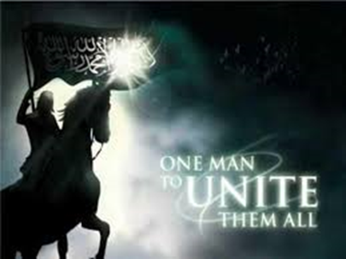
THE WHITE HORSEMAN PRINCE BEAST ANTICHRIST MAHDI RIDES A WHITE ARABIAN STALLION
RIYADH: The Arabian horse is an important historical and cultural symbol for the Arab world, both ancient and modern. Arabian horses have been the subject of songs and poetry praising their individual and physical qualities down through the ages.
https://youtu.be/Au3Y_IaqVkI
https://www.youtube.com/shorts/op1e3dccsro
https://www.youtube.com/shorts/vg_H3hGpllU
https://www.youtube.com/shorts/x_oO3bMUOxw
https://www.youtube.com/shorts/Xv5h0-_Ez2o
JESUS CHRIST IS (7) THE ‘ONE’ WORTHY TO OPEN THE SEALS:
Revelation 6 And I (7) saw when the Lamb opened one of (7) the seals, and I heard, as it (7) were the noise of thunder, one of (7) the four beasts saying, Come and see. (7777)
Revelation 6:2 And I saw, and (7) behold a white horse: and he that (7) sat on him had a bow; and (7) a crown was given unto him: and (7) he went forth conquering, and to conquer. (7777)
Commentary; THE RIDER IS THE ‘BEAST’ OR ‘ANTICHRIST’. His being clothed in white suggests ‘3’ FALSE RIGHTEOUSNESS, FALSE PEACE AND FALSE AUTHORITY. He has a bow, but no arrows. He rules with lies and threats, but no military or arms. He conquers and subjugates, not with force but with ‘5’ LIES, DECEPTION, FALSE COVENANTS AND FALSE AGREEMENTS AND FALSE PROMISES. He is the world’s greatest ‘political’ leader and deceiver. He is the one who ‘confirms the false covenant of seven years with Jacob’ which starts the tribulation. You should know now of who I speak. HIS ‘CROWN’ REPRESENTS AUTHORITY, RULERSHIP AND POSITION. It even literally REPRESENTS HIS ‘POSITION’ AS CROWN PRINCE, once the tribulation begins. My discernment is that THE ‘WHITE HORSE UPON WHICH HE SITS’ IS SYMBOLICALLY A WHITE ARABIAN STALLION.
THE HAVE BEEN PREPARING US FOR YEARS!

https://youtu.be/O3-0ZfcQJpo

HE'S ALREADY ARRIVED BUT PEOPLE DON'T SEE IT...
https://youtu.be/oD9Rkz71XSQ

Concerning world government: society is now about one month away from the WHO meeting (May 27-June 1, 2024) when nations will cast their vote on the International Pandemic Treaty and amendments to the International Health Regulations (IHRs). CONCERNING THE WHO PANDEMIC AGREEMENT, THE FAMILY RESEARCH COUNCIL (FRC) HAS CONCLUDED THAT: THE WHO PANDEMIC AGREEMENT PUTS IN PLACE THE BEGINNINGS OF “A TURNKEY TOTALITARIAN STATE.” FRC’s official comment filed with the U.S. government warns the WHO Pandemic Agreement, as written, “could authorize funding and support for abortion.”
The agreement obligates nations to ENSURE THE PROVISION OF “ESSENTIAL HEALTH CARE SERVICES DURING PANDEMICS,” AND CRITICS SAY ABORTION CAN BE HELD UP AS AN ESSENTIAL SERVICE. Concerning the WHO Pandemic Treaty and the International Health Regulations: on Apr. 25, 2024, presidential candidate Robert F. Kennedy said:
In desperation, watered-down versions of the proposed international health regulations and pandemic treaty were floated over the past few days. Don’t be fooled! THE WHO STILL WANTS EXPERIMENTAL VACCINES ROLLED OUT, STILL WANTS LIABILITY SHIELDS, STILL WANTS TO IMPOSE CENSORSHIP, AND STILL PLANS TO USE ‘ONE HEALTH’ TO CONTROL HUMANS, PLANTS, ANIMALS, AND ECOSYSTEMS, ALL IN THE NAME OF HEALTH.
ACCORDING TO THE BIBLE (REV. 13:2-7), THE WORLD WILL BE RULED BY A SATANIC WORLD GOVERNMENT DURING THE TRIBULATION PERIOD, AND THE WORLD IS ON THE BRINK OF A VOTE THAT WILL PERMIT UNELECTED GODLESS PEOPLE TO ESTABLISH ONE. Concerning the tracking of all buying and selling during the Tribulation Period: a committee in the U.S. House of Representatives is investigating several U.S. government agencies (FBI, etc.) and AT LEAST 13 FINANCIAL INSTITUTIONS (BANK OF AMERICA, CHASE, CITI BANK, WELLS FARGO, ETC.) FOR TRACKING what people bought following the J6 demonstrations at Dick’s Sporting Goods, Cabela’s, Bass Pro Shops, etc., without warrants.
Without getting the required court permission, federal agencies apparently tracked the purchases of private citizens to see if they bought guns, knives, etc. Part of the problem appears to be that federal agencies haven’t limited their tracking of purchases to J6 citizens; they have also tracked millions of other citizens who hold conservative views (called white supremacists, white nationalists, etc.). Simply put, IT LOOKS LIKE BIG GOVERNMENT HAS STARTED SPYING ON AVERAGE AMERICAN CITIZENS WHO ARE POLITICALLY CONSERVATIVE (ESPECIALLY THOSE WHO MIGHT OPPOSE THE GLOBALIST AGENDA or support Make America Great Again).

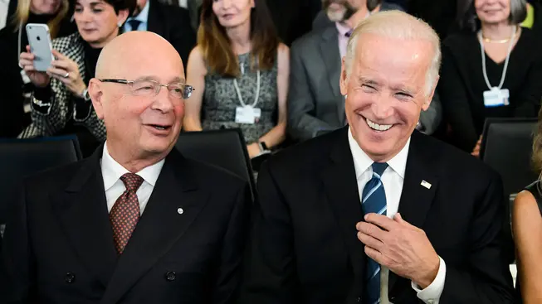
WORLD HEALTH ORGANIZATION IS MAKING A MASSIVE POWER GRAB—AND BIDEN IS ENABLING IT
THE WORLD HEALTH ORGANIZATION WANTS THE POWER TO RUN THE WORLD. IN THREE WEEKS, IT WILL MAKE ITS BID FOR GLOBAL CONTROL.
THE WORLD HEALTH ASSEMBLY, THE 194-MEMBER BODY GOVERNING THAT ORGANIZATION, CONVENES IN GENEVA AT THE END OF MAY. THE MAIN AGENDA ITEMS WILL BE THE AMENDMENT OF THE INTERNATIONAL HEALTH REGULATIONS AND THE SIGNING OF WHAT IS NOW CALLED THE "WHO PANDEMIC AGREEMENT." TOGETHER, THE AMENDMENTS AND AGREEMENT WOULD GIVE WHO, AS THE WORLDWIDE HEALTH BODY IS KNOWN, SWEEPING POWERS BEFORE AND DURING PANDEMICS TO DICTATE ACTIONS OF NATIONAL GOVERNMENTS.
The current version of the agreement, dated April 22 of this year, gives WHO emergency powers to take 10 percent of a country's "pandemic-related health products" and to force the sale of another 10 percent of such products at "affordable prices." The agreement also requires parties to make "annual monetary contributions," but it does not specify terms, conditions, or amounts.
MOREOVER, THE DOCUMENT CONTEMPLATES THE FORCED LICENSING OF TECHNOLOGY, COMMITS COUNTRIES TO A RADICAL "ONE HEALTH APPROACH" COVERING ALL FORMS OF LIFE, and prohibits "national stockpiles of pandemic-related health products that unnecessarily exceed the QUANTITIES ANTICIPATED TO BE NEEDED FOR DOMESTIC PANDEMIC PREPAREDNESS AND RESPONSE." And a signatory to the agreement is required to "set aside a portion of its total procurement of relevant diagnostics, therapeutics, or vaccines in a timely manner for use in counties facing challenges in meeting public health needs and demand."
THE AGREEMENT HAS OPEN-ENDED LANGUAGE, INTENDED TO WORK IN CONJUNCTION WITH THE INTERNATIONAL HEALTH REGULATIONS REGARDING "PUBLIC HEALTH SURVEILLANCE."
The draft agreement states that after adoption, its scope will be spelled out. For example, Article 12's broad "access and benefit-sharing" provisions "shall be further defined in a legally binding instrument that will be operational no later than 31 May 2026." And once in place, obligations can be increased. A CONFERENCE OF THE PARTIES IS GIVEN ESSENTIALLY UNLIMITED POWER TO "TAKE ACTIONS, AS APPROPRIATE, FOR THE ACHIEVEMENT OF THE OBJECTIVE OF THE WHO PANDEMIC AGREEMENT."
Of even greater concern, THE CONFERENCE OF THE PARTIES MAY ON ITS OWN "ADOPT AMENDMENTS TO THE WHO PANDEMIC AGREEMENT."
It appears the provisions of the agreement have, during a long process of negotiation, been watered down to make them acceptable to countries worried about the centralization of power in WHO, but THE CONFERENCE OF THE PARTIES CAN REINSTITUTE THE MOST OBJECTIONABLE OF THE EARLY PROVISIONS—AND EVEN ADOPT MORE ONEROUS ONES.
WHO IS, IN REALITY, ASKING FOR A BLANK CHECK. "THE DEVIL IS IN THE DETAILS AND WHO REFUSES TO SPELL OUT THOSE DETAILS," Reggie Littlejohn, founder of Anti-Globalist International said, referring to the pandemic agreement. "The amendments to the regulations and the adoption of the agreement look like the INSTITUTION OF WORLD GOVERNMENT, 'GLOBAL GOVERNANCE' AS THEY CALL IT," Frank Gaffney, cofounder of the Sovereignty Coalition, said.
Do we need world government? The international community's slow response to the COVID-19 pandemic left much to be desired, but the World Health Organization of Director-General Dr. Tedros Adhanom Ghebreyesus cannot fix the problems. On the contrary, WHO was responsible for helping China turn a one-country epidemic into an almost-every-country pandemic.
Beijing knew that SARS-CoV-2, the pathogen causing COVID-19, was highly transmissible human-to-human no later than the second week of December 2019 but told the world for weeks it was not. WHO spread China's false statements, especially with the organization's January 9, 2020 statement and its January 14 tweet.
WHO knew or had to know its public statements were false. Taiwan on December 31, 2019 informed the health body that coronavirus was contagious to humans, and WHO professionals also knew that to be the case. Maria Van Kerkhove, a senior WHO doctor and a virus expert, said at a press briefing in April 2020 that "right from the start" she thought the coronavirus was H2H, human-to-human contagious. The senior leadership, however, disregarded evidence and warnings when it issued its statement and tweet in January.
Moreover, WHO in public statements supported Beijing's attempt to prevent the imposition of travel bans and quarantines on arrivals from China, publicly backed the reliability of Beijing's statistics on coronavirus infections and deaths, and delayed the declaration of a "public health emergency of international concern" until January 30, 2020 and a "pandemic" until March 11.
TEDROS WAS ELECTED DIRECTOR-GENERAL WITH A MASSIVE EFFORT BY CHINA, AND HE WILL ALMOST CERTAINLY CONTINUE TO ALLOW CHINA TO DICTATE HIS ACTIONS. THIS CONTROL WILL HAVE CONSEQUENCES IF TEDROS GETS EVEN MORE POWER AT THE END OF THIS MONTH. "THE PANDEMIC AGREEMENT IS A WAY FOR CHINA'S REGIME TO IMPOSE ITS TOTALITARIAN MODEL ON THE WORLD THROUGH THE WORLD HEALTH ORGANIZATION," Littlejohn said.
Unfortunately, WHO cannot be fixed. Dr. Xiaoxu Sean Lin, former lab director of the viral disease branch of the Walter Reed Army Institute of Research, says that THE STRUCTURE OF THE ORGANIZATION DEFEATS ACCOUNTABILITY, BECAUSE ITS LEADERS REPORT TO MANY MEMBER STATES AND THEREFORE TO NO ONE. AS A RESULT, UNACCEPTABLE CONDUCT GOES UNPUNISHED. To make matters worse, the Conference of the Parties feature of the pandemic agreement looks designed to defeat accountability.
China has plans. "Beijing Genomics Institute has created the world's largest genetic database and its scientists, along with those of the People's Liberation Army, are using that data to create next-generation bioweapons for 'specific ethnic genetic attacks,' " Brandon Weichert, the author of Biohacked: China's Race to Control Life. "WITH AN ADOPTION OF THE PANDEMIC AGREEMENT, WE HAVE TO REMEMBER THAT THE WORLD HEALTH ORGANIZATION ITSELF HAS BEEN COOPTED AND CORRUPTED BY THE CHINESE REGIME. The powers to be conferred upon the CCP-controlled WHO will not be used to prevent the next pandemic. They will instead be used to help spread it."
"THE NEXT PANDEMIC MIGHT DESTROY US ALL," HE ADDS. YET IT SEEMS THAT THE BIDEN ADMINISTRATION WILL SUPPORT THE AMENDMENTS TO THE INTERNATIONAL HEALTH REGULATIONS AND SIGN THE WHO PANDEMIC AGREEMENT.

THE WORLD HEALTH ORGANIZATION IS CREATING A NEW ‘PANDEMIC INDUSTRY’
https://www.theepochtimes.com/epochtv/the-world-health-organization-is-creating-a-new-pandemic-industry-philipp-kruse-5622150
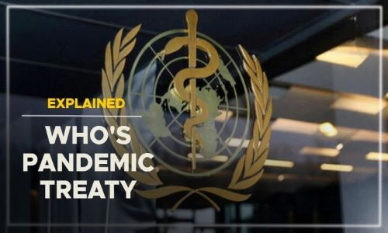
ONE MONTH UNTIL WHO PANDEMIC AGREEMENT USURPS U.S. SOVEREIGNTY
Americans stand just weeks away from handing over massive amounts of taxpayer funding, protective equipment intended for U.S. citizens, and an incalculable amount of influence over U.S. policy to the World Health Organization (WHO), critics warn.
The global governance body will resume meetings to revise the WHO Pandemic Agreement on Monday. The Intergovernmental Negotiating Body (INB), established to draw up the text of the agreement in December 2021, will hold its ninth meeting from April 29 to May 10. That provides just over two weeks before the 77TH WORLD HEALTH ASSEMBLY MEETS FROM MAY 27 TO JUNE 1 IN GENEVA, SWITZERLAND, TO RATIFY THE FINAL DOCUMENT.
The most recently updated version of the "PROPOSAL FOR THE WHO PANDEMIC AGREEMENT," amended on April 22, would redistribute wealth and protective equipment away from the U.S., establish a global governing board with little accountability to U.S. citizens and, critics say, water down U.S. sovereignty over how it responds to future pandemics.
The latest version of the agreement calls on nations to ADOPT "WHOLE-OF-GOVERNMENT AND WHOLE-OF-SOCIETY APPROACHES" to pandemics, "including the private sector and civil society." GOVERNMENTS SHOULD CARRY OUT SO-CALLED EDUCATION PROGRAMS THAT WILL SUPPRESS COMPETING NARRATIVES ABOUT THE PANDEMIC, as the U.S. government did during COVID-19.
Nations must also conduct research to determine what forces "hinder or strengthen adherence to public health and social measures in a pandemic," such as MASK AND VACCINE MANDATES.
WHO makes clear it intends to involve itself far beyond the physical aspects of the outbreak. The latest agreement invokes the "public health impact of growing threats such as climate change, poverty and hunger." Fighting pandemics, it states, requires nations to "achieve greater health equity" by taking "resolute action on the social, environmental, cultural, political and economic determinants of health." This includes adopting a controversial "OneHealth" approach, which attempts to "balance" the "health of people, animals and ecosystems" as though all were equally valuable.
Nations have the right to "adopt legislation" only "in accordance with the Charter of the United Nations, the WHO Constitution and the principles of international law, and their sovereign rights over their biological resources." They also MAY NOT MAKE RESERVATIONS THAT ARE "INCOMPATIBLE WITH THE OBJECT AND PURPOSE OF THE WHO PANDEMIC AGREEMENT," as determined by the WHO.
Aside from incursions onto national prerogatives spelled out in the WHO Pandemic Agreement, the document establishes a "CONFERENCE OF THE PARTIES," A GROUP OF UNELECTED OFFICIALS EMPOWERED TO ADOPT NEW RESOLUTIONS THAT WILL BE LEGALLY BINDING UPON SIGNATORIES. The text makes the WHO pandemic arrangement easy to get into but hard to leave. ONCE A NATION SIGNS ONTO THE ACCORD, IT "SHALL NOT BE DISCHARGED" FROM ANY "OBLIGATIONS WHICH ACCRUED WHILE IT WAS A PARTY TO THE WHO PANDEMIC AGREEMENT," even after it withdraws.
The controversial document mandates that all nations assure "real-time access by WHO to 20%" of all "products that are needed for pandemic prevention, preparedness and response": "10% as a donation" and 10% at "affordable prices.: WHO, in turn, will create "a mechanism to ensure the fair and equitable allocation and distribution of the pandemic-related health products" globally. Nations will agree to "prioritize sharing through" the WHO'S NEWLY-ESTABLISHED "GLOBAL SUPPLY CHAIN AND LOGISTICS NETWORK ... over bilateral donation agreements" adopted with allied nations. EVERY NATION "SHALL" ALSO CREATE A "GLOBAL HEALTH EMERGENCY WORKFORCE DEPLOYABLE TO SUPPORT [OTHER SIGNATORIES] UPON REQUEST" OF WHO.
State-to-state foreign aid amounts to wealth transfers to "up-and-coming young oligarchs in smaller nations," journalist Jim Roguski told "Washington Watch with Tony Perkins" on Wednesday. As a result, WEALTHY NATIONS WILL "PUT A LOT OF MONEY INTO BUILDING OUT THE PHARMACEUTICAL HOSPITAL EMERGENCY INDUSTRIAL COMPLEX IN POOR NATIONS -- not to give that money or support to poor people in poor nations, but to give it to wealthy people in poor nations so that they can jab them the next time around."
FAMILY RESEARCH COUNCIL HAS CONCLUDED THAT THE WHO PANDEMIC AGREEMENT PUTS IN PLACE THE BEGINNINGS OF "A TURNKEY TOTALITARIAN STATE." FRC's official comment filed with the U.S. government warns the WHO Pandemic Agreement, as written, "could authorize funding and support for abortion." The agreement obligates nations to assure the provision of "essential health care services during pandemics," and critics say, abortion can be held up as an essential service.
Observers warned readers against viewing the newest text as a modestly less intrusive document than some previous versions. "In desperation, watered-down versions of the proposed international health regulations and pandemic treaty were floated over the past few days. Don't be fooled! The WHO still wants experimental vaccines rolled out, still wants liability shields, still wants to impose censorship, and still plans to use 'One Health' to control humans, plants, animals, and ecosystems, all in the name of health," said independent presidential candidate Robert F. Kennedy Jr. on Thursday.
The undemocratic mechanisms written into the agreement did not surprise Roguski. "Back in 2022, they pretended to adopt amendments to five articles, but they never bothered to vote" on them. Yet, despite the lack of a vote, those amendments will take force on May 31, he said. "The good news is that they are having a difficult time," Roguski told Perkins, BREAKING OUT HIGH-PRESSURE SALES TACTICS FOR NATIONS TO SIGN ONTO THE ACCORD.
"Pressure to act swiftly or risk missing out on the treaty's promise effectively warns LMICs [Low- and Middle-Income Countries] that this is their sole opportunity, insisting they must conform to the timeline," wrote Sarah Hodges, professor of Global Health and Social Medicine at King's College London. "However, this rapid pace raises concerns about what we refer to as 'time equity' -- the fair allocation of time and resources for deliberation and decision-making among all stakeholders."
WHO OFFICIALS ARE ALSO PUMPING UP FEAR ABOUT DEADLY, BUT HYPOTHETICAL, FUTURE OUTBREAKS.
Kate Bingham and Tim Hames of the WHO warn in a new book, "The Long Shot," that a THEORETICAL "DISEASE X" COULD BECOME THE NEXT PANDEMIC AND WIPE OUT 50 MILLION PEOPLE WORLDWIDE. WHO HAS SMEARED ITS OPPONENTS AS PURVEYORS OF MISINFORMATION AND DISINFORMATION. In March, former U.K. Prime Minister Gordon Brown -- who is now WHO ambassador for global health finance -- insisted, "It is time for countries to expose fake news disinformation campaigns by conspiracy theorists to torpedo a much-needed accord." Brown warned that "governments must work to disavow them with clear facts," and doing so "will be a test of our ability as a global community to resist the fragmentation of our world and instead cooperate on global problems that need global solutions."
THE POTENTIAL TOLL TO PRIVACY FROM A GLOBAL PANDEMIC ORDER COULD BE REAL AND STIGMATIZING, "THEY WANT PAPERWORK THAT SAYS YOU'VE BEEN INJECTED WITH SOME SUBSTANCE, AND IF YOU DON'T MEET THOSE REQUIREMENTS, YOU ARE SUDDENLY DANGEROUS TO YOUR FELLOW MAN OR WOMAN."
Others around the world feared the impact of the WHO once emboldened to act with greater authority. "Once approved, the WHO will have total powers and control over matters to do with health and climate change," said Kenyan politician Steve Mbogo. "The depopulation agenda is wide and clear."
Despite the WHO's claim to act as the global authority, newly published data prove that lockdowns worsened other health outcomes. WHO recently revealed the number of children vaccinated against other diseases, such as diphtheria, plummeted by six million between 2018 and 2021 and remained 2% lower than pre-pandemic levels in 2022. "You're in the battle of your life to crush this attempt" to erode "our SACRED RIGHT TO BE IN CONTROL OF OUR OWN BODY, MAKE OUR OWN HEALTH DECISIONS," said Roguski.

THE WORLD HEALTH ASSEMBLY IS THE DECISION-MAKING BODY OF WHO
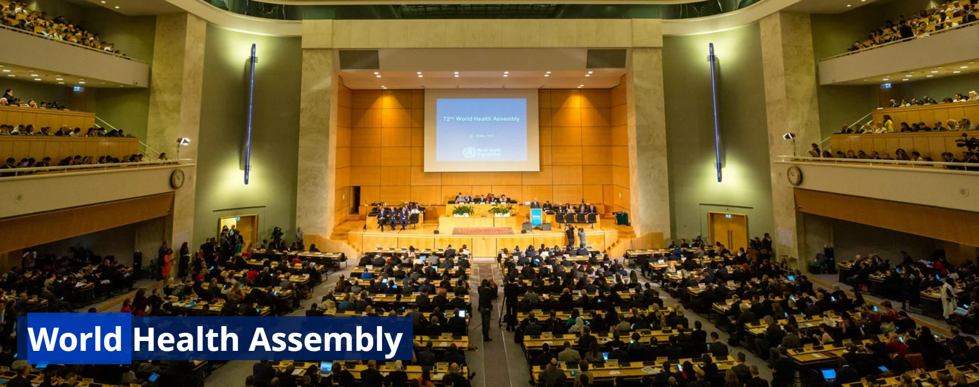
It is attended by delegations from all WHO Member States and focuses on a specific health agenda prepared by the Executive Board. The main functions of the World Health Assembly are to determine the policies of the Organization, appoint the Director-General, supervise financial policies, and review and approve the proposed programme budget. The Health Assembly is held annually in Geneva, Switzerland.
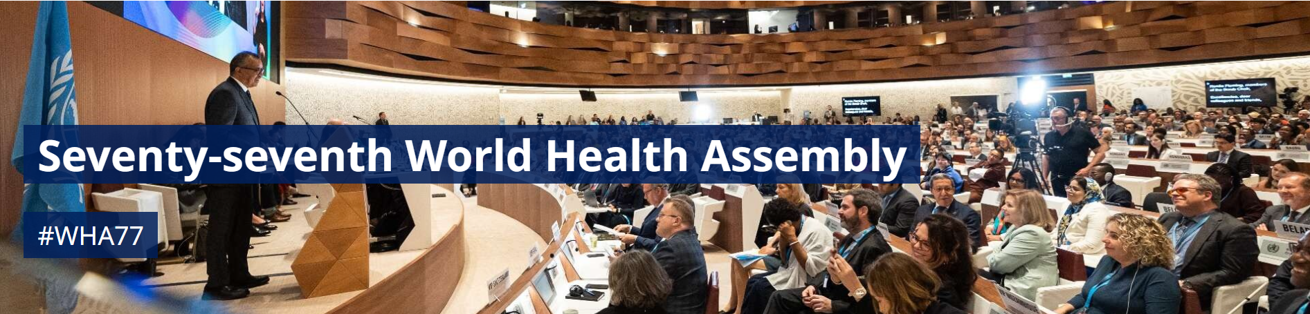
The SEVENTY-SEVENTH WORLD HEALTH ASSEMBLY is being held in Geneva, Switzerland, on 27 May – 1 June 2024. The theme of this year’s Health Assembly is: All for Health, Health for All. During the Seventy-seventh World Health Assembly, a series of strategic roundtables will be held. During these sessions, WHA delegates, partner agencies, representatives of civil society and WHO experts will discuss current and future priorities for public health issues of global importance.
Pillar 1: One billion more people benefiting from universal health coverage
Pillar 2: One billion more people better protected from health emergencies
Pillar 3: One billion more people enjoying better health and well-being
Pillar 4: More effective and efficient WHO providing better support to countries
COLLABORATION WITH OTHER INTERGOVERNMENTAL ORGANIZATIONS
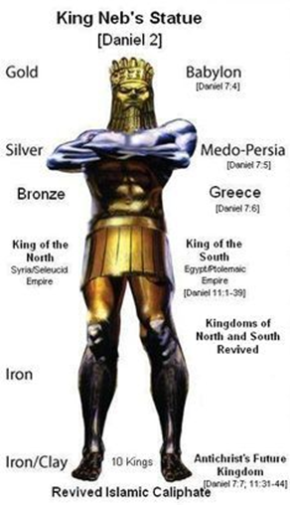
WHO’S CONTRIBUTIONS TO EUROPEAN UNION (EU) POLICIES AND STRATEGIES IMPROVE PUBLIC HEALTH IN THE EU AND GLOBALLY. WHO COLLABORATES WITH EU INSTITUTIONS, MEMBER STATES AND CIVIL SOCIETY, to ensure thematic and strategic engagement for global health.
WHO ADVOCATES FOR THE INTEGRATION OF WHO’S EVIDENCE-BASED POLICIES IN KEY EU INITIATIVES SUCH AS THE EUROPEAN HEALTH UNION, THE EU HEALTH SECURITY FRAMEWORK AND THE NEW EU GLOBAL HEALTH STRATEGY. Recognizing WHO as a central partner in global health governance, THE EU GLOBAL HEALTH STRATEGY EMPHASIZES STRENGTHENED COLLABORATION TO ACHIEVE COMMON HEALTH OBJECTIVES.
This partnership has aligned priorities and resulted in the ADOPTION OF EUROPEAN COUNCIL CONCLUSIONS IN JANUARY 2024 PLACING GLOBAL HEALTH AT THE FOREFRONT OF THE EU’S AGENDA. WHO’S PARTNERSHIP WITH THE EUROPEAN COMMISSION INCLUDES ACTIVE COOPERATION ACROSS DIRECTORATES AND SERVICES, AND COLLABORATION WITH OTHER EU BODIES AND AGENCIES. STRATEGIC DISCUSSIONS AND SENIOR OFFICIAL MEETINGS BETWEEN WHO AND THE EU FACILITATE EXCHANGES ON KEY HEALTH PRIORITIES, AND HAVE LED TO THE GLOBAL DIGITAL HEALTH CERTIFICATION NETWORK, THE EXTENSION OF THE UNIVERSAL HEALTH COVERAGE PARTNERSHIP.
IN 2023, WHO CONTINUED STRATEGIC INTERACTION WITH THE EU COUNCIL THROUGH SUPPORT AND COLLABORATION WITH EU MEMBER STATES. IN ADDITION, WHO PRIORITIZED EFFORTS TO STRENGTHEN PARTNERSHIPS WITH THE EU AND ENHANCE COUNTRY ENGAGEMENT ON GLOBAL HEALTH PRIORITIES.
WHO supports the United Nations Funding Compact, a mechanism TO ACCELERATE ACHIEVEMENT OF AGENDA 2030, by strengthening the Organization’s programmatic, financial and governance processes, and accountability mechanisms. Examples of progress include ALIGNMENT OF ALL WHO COUNTRY COOPERATION STRATEGIES WITH THE UNITED NATIONS SUSTAINABLE DEVELOPMENT COOPERATION FRAMEWORK

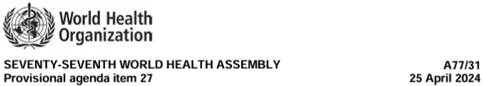
A SUMMARY OF WHO’S ENGAGEMENT WITH THE UNITED NATIONS AND OTHER INTERGOVERNMENTAL ORGANIZATIONS TO ADVANCE THE HEALTH AGENDA AND ACHIEVE THE SUSTAINABLE DEVELOPMENT GOALS
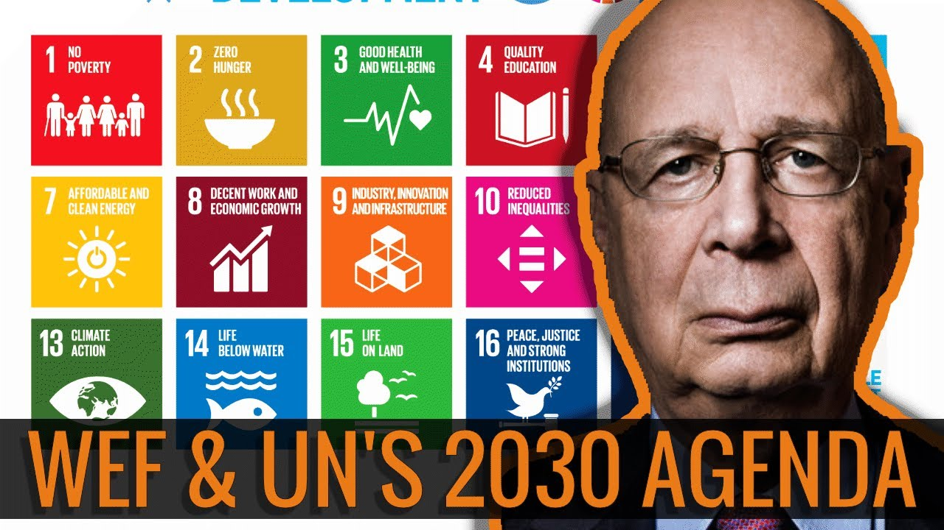
- WHO SUPPORTED MEMBER STATES WITHIN THE MAIN BODIES OF THE UNITED NATIONS, INCLUDING THE ECONOMIC AND SOCIAL COUNCIL, THE SECURITY COUNCIL AND THE GENERAL ASSEMBLY. WHO AIMED TO POSITION HEALTH IN THE DEVELOPMENT NARRATIVE AND UNITED NATIONS PROCESSES.
- WHO PROVIDED TECHNICAL GUIDANCE FOR GENERAL ASSEMBLY RESOLUTIONS, including resolution: 77/287, “COMMUNITY-BASED PRIMARY HEALTH CARE: A PARTICIPATORY AND INCLUSIVE APPROACH TO UNIVERSAL HEALTH COVERAGE”.
- WHO participated in the 2023 United Nations Water Conference, supporting the achievement of Sustainable Development Goal (SDG)
- WHO ENGAGED WITH UNITED NATIONS PARTNERS TO HEIGHTEN VISIBILITY OF GLOBAL HEALTH PRIORITIES AND PROVIDED TECHNICAL AND STRATEGIC GUIDANCE TO THOSE ADVOCATING FOR: UNIVERSAL HEALTH COVERAGE, SOLIDARITY FOR GLOBAL HEALTH SECURITY. WHO COLLABORATED WITH THESE GROUPS TO BUILD POLITICAL WILL AND RAISE THE PROFILE OF HEALTH WITHIN THE UNITED NATIONS SYSTEM.
- WHO participated in Economic and Social Council thematic sessions including: the Coordination Segment, where WHO PROMOTED THE USE OF DIGITAL TECHNOLOGIES IN HEALTH AND FOOD SECURITY; the COMMISSION ON POPULATION AND DEVELOPMENT BRIEFING. WHO EMPHASIZED THE IMPORTANCE OF HEALTH EQUITY AND PARTICIPATED IN DISCUSSIONS ON DIGITAL ACCESSIBILITY AND REPRODUCTIVE HEALTH SERVICES.
- During the high-level week of the seventy-eighth session of the General Assembly, WHO co-sponsored side events concerning children with developmental disabilities, UNIVERSAL HEALTH COVERAGE GLOBAL MONITORING, STRENGTHENED MONITORING AND ACCOUNTABILITY TO PREVENT THE NEXT PANDEMIC, child survival in hunger and malnutrition crises, the Pandemic Fund, mental health, the Tuberculosis Vaccine Accelerator Council, the Global Noncommunicable Disease Compact, PRIMARY HEALTH CARE INVESTMENT TO ACHIEVE UNIVERSAL HEALTH COVERAGE, ADVANCEMENT TOWARDS SDG THREE (ENSURE HEALTHY LIVES AND PROMOTE WELL-BEING FOR ALL AT ALL AGES) AND HEALTH SECURITY, ACCESS TO MEDICAL COUNTERMEASURES AGAINST PANDEMIC THREATS, and the Global Initiative for Childhood Cancer.
- WHO ENGAGED WITH THE SECURITY COUNCIL ON HEALTH ISSUES RELATED TO ‘INTERNATIONAL PEACE AND SECURITY’. On 10 November 2023, the WHO Director-General briefed the Security Council on the health situation and humanitarian needs in Israel, Gaza and the West Bank. WHO followed Security Council meetings on Afghanistan, the Democratic Republic of the Congo, Haiti, Somalia, Sudan, the Syrian Arab Republic, Ukraine and Yemen.
- On 20 September 2023, the President of the General Assembly convened the HIGH-LEVEL MEETING ON PANDEMIC PREVENTION, PREPAREDNESS AND RESPONSE. The political declaration, adopted on 5 October 2023, ENHANCES POLITICAL SUPPORT FOR WHO AND COMMITS GOVERNMENTS TO TAKE CONCRETE STEPS TO STRENGTHEN THE GLOBAL HEALTH ARCHITECTURE, ENSURE EQUITY AND STRENGTHEN COUNTRY-LEVEL CAPACITY.
- On 21 September 2023, the President of the General Assembly convened the high-level meeting on UNIVERSAL HEALTH COVERAGE. The political declaration, adopted on 5 October 2023, outlines a GLOBAL STRATEGY TO IMPROVE HEALTH OUTCOMES AND ACHIEVE UNIVERSAL HEALTH COVERAGE. The strategy emphasizes the importance of collaboration and innovation and the need to address the social determinants of health in order to build resilient health systems and achieve the SDGs.
- WHO ENGAGED WITH THE SUSTAINABLE DEVELOPMENT GROUP, WHICH COORDINATES THE UNITED NATIONS SYSTEM TO SUPPORT MEMBER STATES’ ACHIEVEMENT OF THE SDGS.

ONE BILLION MORE PEOPLE BENEFITING FROM UNIVERSAL HEALTH COVERAGE
UNIVERSAL HEALTH COVERAGE
The Executive Board at its 154th session noted the report on universal health coverage.2 It adopted decision EB154(6) on development of a global strategy and action plan for integrated emergency, critical and operative care, 2026–2035, in which it recommended to the Health Assembly the development of such a strategy for consideration by the Seventy-ninth World Health Assembly, through the Executive Board at its 158th session. It also considered the text of A DRAFT RESOLUTION INTRODUCED BY MEMBER STATES ON SOCIAL PARTICIPATION FOR UNIVERSAL HEALTH COVERAGE, HEALTH AND WELL-BEING.
The Board agreed that consultations on the draft resolution would continue during the intersessional period. In the discussions, BOARD MEMBERS ACKNOWLEDGED THE DECLARATION OF THE UNITED NATIONS GENERAL ASSEMBLY ON UNIVERSAL HEALTH COVERAGE AND THE CENTRAL ROLE OF REORIENTING HEALTH SYSTEMS TOWARDS A PRIMARY HEALTH CARE APPROACH IN ACHIEVING UNIVERSAL HEALTH COVERAGE. THEY AFFIRMED THAT UNIVERSAL HEALTH COVERAGE AND STRONG HEALTH SYSTEMS SHOULD UNDERPIN THE DRAFT FOURTEENTH GENERAL PROGRAMME OF WORK.
DRAFT GLOBAL ACTION PLAN FOR INFECTION PREVENTION AND CONTROL
The Executive Board at its 154th session noted the report concerning the DRAFT GLOBAL ACTION PLAN FOR INFECTION PREVENTION AND CONTROL. It adopted decision EB154(8) in which it recommended to the Health Assembly the adoption of the global action plan and monitoring FRAMEWORK ON INFECTION PREVENTION AND CONTROL, 2024–2030.
IMMUNIZATION AGENDA 2030
The Executive Board at its 154th session noted the report on the IMMUNIZATION AGENDA 2030. In the discussions, Board members voiced support for the shared action agenda and its six short-term priority areas, and especially the “BIG CATCH-UP” INITIATIVE. THEY EXPRESSED CONCERN OVER THE RISING NUMBER OF OUTBREAKS, PARTICULARLY MEASLES, AND UNDERSCORED THE NEED FOR RECOVERY OF COVERAGE LEVELS AND CATCH-UP OF CHILDREN MISSED DURING THE COVID-19 PANDEMIC.

WHO’S WORK IN HEALTH EMERGENCIES
The Executive Board at its 154th session noted the reports on public health emergencies: preparedness and response; STRENGTHENING THE GLOBAL ARCHITECTURE FOR HEALTH EMERGENCY PREPAREDNESS, PREVENTION, AND RESPONSE AND RESILIENCE; and health conditions in the OCCUPIED PALESTINIAN TERRITORY, INCLUDING EAST JERUSALEM. It adopted decisions EB154(9) on the universal health and preparedness review and EB154(10) on STRENGTHENING LABORATORY BIOLOGICAL RISK MANAGEMENT.
GLOBAL HEALTH AND PEACE INITIATIVE
The Executive Board at its 154th session noted the report on the GLOBAL HEALTH AND PEACE INITIATIVE. It also adopted decision EB154(11), in which it recommended to the Health Assembly, inter alia, continued support for EVIDENCE GATHERING, COMMUNICATION AND DIALOGUE AS PART OF THE CONSULTATIVE PROCESS OF STRENGTHENING THE ROADMAP FOR THE GLOBAL HEALTH AND PEACE INITIATIVE and submission of a status report on the Roadmap to the Health Assembly in 2029.
CLIMATE CHANGE AND HEALTH
The Executive Board at its 154th session noted the REPORT ON CLIMATE CHANGE and health and considered the text of a draft resolution introduced by Member States on the same topic. In the discussions, Board members observed that the CLIMATE CRISIS WAS A HEALTH CRISIS and welcomed the Secretariat’s efforts to IMPROVE MEMBER STATES’ CAPACITIES TO RESPOND TO THE IMPACTS OF CLIMATE CHANGE ON HEALTH WHILE PROMOTING LOW CARBON SOCIETIES AND HEALTH SYSTEMS.

THE DECEPTION OF ‘ONE HEALTH’: WHAT WILL WORLD LEADERS BE WILLING TO GIVE UP?
The world is just a few weeks away from the global acceptance of the World Health Organization PANDEMIC TREATY, KNOWN AS WHO. THIS TREATY INCLUDES THE “ONE HEALTH” AGENDA and is designed to “balance” the health of people, animals, and plants, as though all three are of equal value.
ONE HEALTH
Adopting the “One Health” approach will affect multiple aspects of everyday life, from agriculture and farming to livestock and food production to environmental issues. THE “ONE HEALTH” AGENDA IS DESIGNED TO GLOBALLY DECLARE POSSIBLE PANDEMIC-TYPE RISKS, WHICH WILL NATURALLY LEAD TO FORCED LOCKDOWNS AND RESTRICTIONS PLACED UPON THE PRIVATE SECTOR. THE SOLUTION WILL BE MORE MASS VACCINATIONS AND, FOR THE SAFETY OF THE GENERAL PUBLIC, MORE TYPES OF SURVEILLANCE ON PRIVATE CITIZENS.
In 2018, the National One Health Steering Committee (NOHSC) and Technical Working Groups (TWG) agreed to a FIVE-YEAR STRATEGIC PLAN. PART OF THAT STRATEGIC PLAN IS THE GLOBAL HEALTH SECURITY AGENDA. What is that? THE GLOBAL HEALTH SECURITY AGENDA (GHSA) IS A GLOBAL EFFORT TO STRENGTHEN THE WORLD’S ABILITY TO PREVENT, DETECT, AND RESPOND TO INFECTIOUS DISEASE THREATS. MORE THAN 70 COUNTRIES, INCLUDING THE UNITED STATES, HAVE SIGNED ONTO THE GHSA FRAMEWORK. The U.S. Centers for Disease Control and Prevention (CDC), which works directly with other governments, plays a leading role in supporting progress towards the GHSA’s targeted goals for 2024.
WHO PANDEMIC AGREEMENT
The most recently updated version of the WHO Pandemic Agreement, last amended on April 22, is designed to redistribute wealth and protective equipment away from the U.S. and establish a global governing board with little accountability to U.S. citizens. WHO has made it clear that it intends to involve itself far beyond the aspects of possible pandemic outbreaks. The latest agreement calls for WHO to be hands-on with such items as climate change, poverty, and hunger.
Some will say this is all about money—pharmacies, hospitals, and those who gain financially. However, according to a Wall Street Journal article from April 2021, forty new billionaires were created, and over 200,000 small businesses were destroyed in the U.S. in 2020 alone. The last pandemic was not about wealth; it was about wealth transfer.
When this pandemic agreement becomes binding, nations will still have the right to adopt laws, but only per the Charter of the United Nations and the WHO constitution. COUNTRIES CANNOT MAKE CHANGES THAT ARE INCOMPATIBLE WITH THE WHO PANDEMIC AGREEMENT.
SUPPORT FOR ABORTION
The WHO Pandemic Agreement, as it is written, would authorize funding and support for abortion. The agreement obligates nations during pandemics to ensure the provision of essential healthcare services, which means abortion would be considered an essential service.
DISEASE X
Kate Bingham and Tim Hames of the WHO, using fear as a tool, warn in their book, The Long Shot: The Inside Story of the Race to Vaccinate Britain, which was released in March of 2023, paint the picture of a hypothetical disease such as “DISEASE X” WHICH COULD BECOME THE NEXT PANDEMIC AND KILL FIFTY MILLION PEOPLE WORLDWIDE. They open their book by saying this is the work of two authors but one voice. Proposing a pandemic designed to kill fifty million people may be the work of many authors, but the one voice they are listening to is not God. Second Timothy says God did not give us the spirit of fear.

WORLD HEALTH ASSEMBLY
FROM MAY 27 TO JUNE 1 IN GENEVA, SWITZERLAND, THE 77TH WORLD HEALTH ASSEMBLY WILL MEET TO FINALIZE THESE AGREEMENTS. THIS WILL DICTATE HOW THE UNITED STATES AND THE WORLD RESPOND TO ANY FUTURE PANDEMICS.
As of now, the WHO pandemic agreement is easy to enter but almost impossible to leave. The language of this agreement is designed so that once a nation signs onto the accord, it “shall not be discharged” from any “obligations which happened while it was a Party to the WHO Pandemic Agreement,” even after it withdraws.
A TREATY, AN AGREEMENT, OR A FRAMEWORK?
It is pointed out that the WHO refuses to call this treaty a treaty; they are calling it an agreement or a framework. If it is called a treaty, it would have to be submitted to the treaty process in the United States, which could delay or even derail this agreement.
Congressman Smith says, “THIS IS ON A FAST TRACK. MUCH OF THIS HAS BEEN DONE WITHOUT VERY MUCH SCRUTINY OR INSIGHT. HOWEVER, WE DO KNOW FROM THE DRAFT OF THIS PANDEMIC TREATY THAT IT WILL BE BINDING. THEY SAY IT RIGHT IN THE TREATY. IT WILL BE AS IF THE U.S. CONGRESS AND THE PRESIDENT SIGNED A LAW THAT DOES ALL THESE THINGS.”
ARTICLE 6
Smith confirmed it is evident in Article 6 of this agreement that it promotes abortion on demand. He said the World Health Organization (WHO) Secretary-General has entered into agreements with several pro-abortion groups, including Planned Parenthood, a group out of the European Union, and the Center for Reproductive Rights. He said there are no gestational limits on abortion right up until the moment of birth. He also points out that this agreement does not protect healthcare professionals, including doctors, who don’t want to be participants.
The press conference acknowledges:
THIS TREATY OR AGREEMENT CALLS FOR SURVEILLANCE AND DIGITAL I.D.S. THIS TREATY SETS THE STAGE FOR THE ANTICHRIST SYSTEM DESCRIBED IN REVELATION 13. THE FUTURE ANTICHRIST SYSTEM WILL LEAD TO THE DEMAND FOR THE GLOBAL WORSHIPPING OF THE BEAST. (REVELATION 13:15). SCRIPTURE TELLS US THIS COMING ONE WORLD LEADER WILL HAVE AUTHORITY OVER “EVERY TRIBE, PEOPLE, LANGUAGE AND NATION.” (REVELATION 13:7). IF NATIONS TODAY ARE WILLING TO GIVE UP SOVEREIGNTY FOR A PROPOSED PANDEMIC TREATY, WHAT WILL THE WORLD LEADERS BE WILLING TO GIVE UP IN THE TRIBULATION PERIOD.

HUMANS, ANIMALS, AND PLANTS
The WHO still plans to use “One Health” as a vehicle to control humans, plants, and animals—all in the name of environmental health. Once this treaty is approved, the WHO will have total power and control over matters related to health and Climate Change.
THIS GLOBAL EFFORT IS PART OF THE UNITED NATIONS SUSTAINABLE DEVELOPMENT PROGRAM. IN FACT, THE WHITE HOUSE ISSUED A FACT SHEET IN FEBRUARY 2022 ENDORSING THE UNITED STATES’ COMMITMENT TO THE GLOBAL HEALTH SECURITY AGENDA. You can find this fact sheet on the White House’s website.
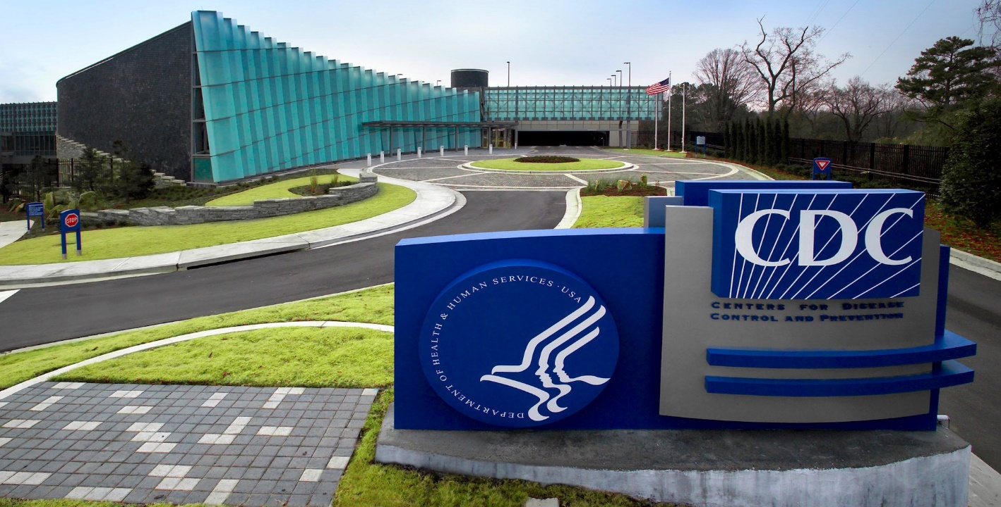
CENTER FOR DISEASE CONTROL: CDC
In America, the CDC and the Center for Disease Control will be the arm pushing this agenda. It seems the Global Health Security Agency is on track to reach its 2024 GOAL OF GLOBAL ACCEPTANCE AND FINALIZING THE WORLD’S FIRST PANDEMIC AGREEMENT.
THE GLOBAL HEALTH SECURITY AGENDA (GHSA), THE WHO PANDEMIC AGREEMENT, AND “ONE HEALTH” may soon become reality. The WHO pandemic treaty is to be voted on later this month. It requires a two-thirds majority vote to pass. THE “ONE HEALTH” AGENDA will cover multiple aspects of everyday life. From our diets to our healthcare, how and where the population can live and work, to deciding what constitutes water and land pollution. There will not be an aspect of life as we know it that will not be influenced by this proposed treaty.

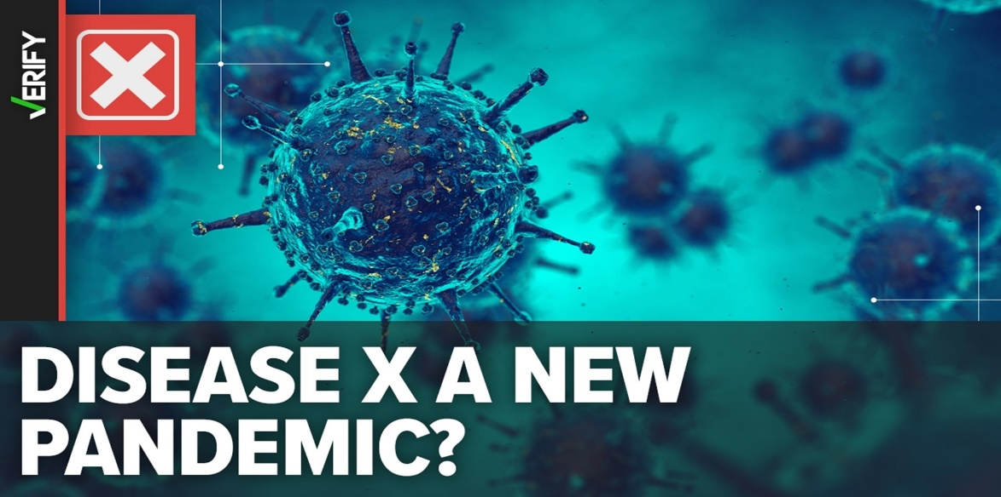
DISEASE X IS BEING ‘COOKED UP RIGHT BEFORE WHO TREATY VOTE’
https://rumble.com/v4tna1t-title-dr.-peter-mccullough-disease-x-is-being-cooked-up-right-before-who-tr.html
The World Health Organization (WHO) is on the verge of gaining immense pandemic powers, and Dr. Peter McCullough believes disease X could lead to a new public health "emergency."
Additionally, Dr. McCullough, a cardiologist and chief scientific officer for The Wellness Company, warned that disease X is being ramped up in the mainstream media as the World Health Organization (WHO) is set to vote on a new pandemic treaty in May 2024 that would sign away U.S. sovereignty in the event of a public health “crisis.”
https://youtu.be/0O4n5Cf75ZM

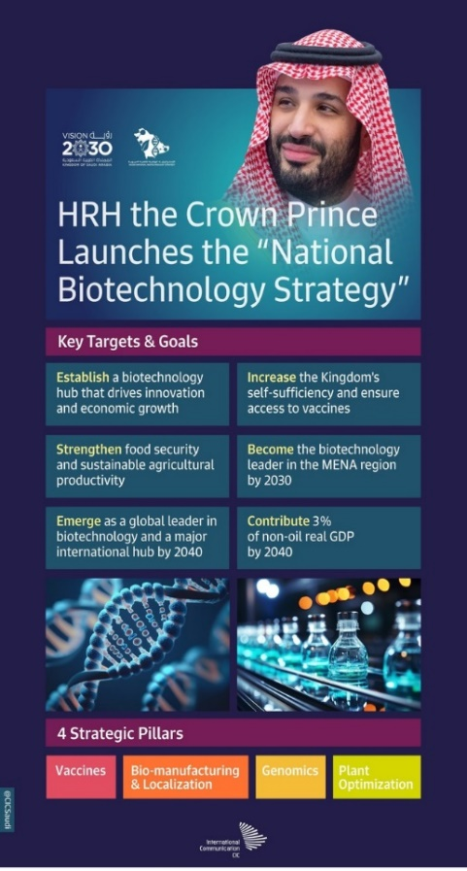

NEW INITIATIVE AIMS TO REINFORCE SAUDI ARABIA’S BIOTECH LEADERSHIP POSITION
SAUDI ARABIA IS NOT ONLY THE MIDDLE EAST’S LARGEST REGIONAL MARKET FOR PHARMACEUTICALS AND VACCINES, BUT ALSO HAS BEEN STRATEGICALLY INVESTING IN BIOTECHNOLOGY-RELATED SECTORS. The country’s genetic diversity and geographical climate provide ideal conditions for conducting complex studies and research.
It has also been clear that the Kingdom is committed to developing and training national talent in biotech research, development and innovation, while ENABLING A COMPETITIVE AND DIGITAL INFRASTRUCTURE.
THE NEW NATIONAL BIOTECHNOLOGY STRATEGY, UNVEILED BY CROWN PRINCE MOHAMMED BIN SALMAN LAST WEEK, IS THE LATEST SHOT IN THE ARM FOR SUCH FIELDS AS BIOMANUFACTURING, FOOD, GENOMICS, VACCINE INDUSTRIES AND PLANT OPTIMIZATION. LOCALIZING VACCINE MANUFACTURING and improving the health of Saudi citizens are among the key goals of the strategy. but that is just for a start.
Welcoming the announcement, Rabia Yasmeen, a senior consultant at Dubai-based strategic market research company Euromonitor International, told Arab News: “Saudi Arabia continues to seek new areas of economic diversification as part of its VISION 2030 PLAN, which is now only six years away, and BIOTECHNOLOGY CAN BRING IMMENSE VALUE ACROSS VARIOUS PILLARS FOR THE KINGDOM.
“Not only does it have the potential to address and to treat a wide range of diseases, but it can inherently improve the quality and longevity of human life.” At its most basic, biotech is a process utilizing cellular and biomolecular processes to develop technologies and products, with a HISTORY DATING BACK MORE THAN 6,000 YEARS and boasting produce including bread and cheese. More recently, it has grown ties to the DEVELOPMENT OF THERAPEUTIC PROTEINS AND DRUGS CONSTITUTED THROUGH GENETIC ENGINEERING TO TREAT A RANGE OF AILMENTS.
All of which will only be aided by SAUDI ARABIA’S PUSH INTO GENOMICS. SEEN AS MEDICINE’S NEW FRONTIER, THE FIELD FOCUSES ON THE INTERACTION AMONG GENES and their interactions with environments.
Yasmeen said that GENOMICS AND PRECISION MEDICINE CAN BE THE NEXT KEY AREAS OF FOCUS FOR THE GOVERNMENT, adding that Saudi Arabia’s large public healthcare sector coupled with the cost of medical services is an emerging source of concern. “GENOMICS TECHNOLOGY CAN OFFER THE INNOVATION THAT IS NEEDED TO MANAGE THESE COSTS,” she said. “But, more importantly, it can help Saudi Arabia tackle challenges in its healthcare landscape such as high obesity levels, DEVELOP MEDICINES UNIQUE TO THE KINGDOM’S GENOME PROFILE, AS WELL AS DEVELOP NEW GENOME PROFILES THAT CAN OPTIMIZE THE POPULATION’S PRODUCTIVITY AND HEALTH.”
According to Jassim Al-Shammari, founder of the think tank Saudi Industrialists and Exporters Platform, the NATIONAL BIOTECHNOLOGY STRATEGY WILL BE A PIVOTAL IN THE DEVELOPMENT OF SAUDI ARABIA’S ECONOMY, RESULTING IN A “STRONG PHARMACEUTICAL INDUSTRY IN THE KINGDOM. “It will reduce dependence on imports and increase self-sufficiency in meeting the needs of domestic markets, enhancing economic autonomy and reducing dependence,” he told Sabq, an electronic newspaper in Arabic.
Al-Shammari added that the “NEW STRATEGY PROMOTED DIGITAL TRANSFORMATION AND TECHNOLOGICAL ADVANCEMENT IN PHARMACEUTICAL INDUSTRIES, WHERE BIOTECHNOLOGY COULD BE USED TO IMPROVE INDUSTRIAL PROCESSES AND DEVELOP NEW, EFFECTIVE AND SAFE MEDICINES.” A report published last year by Strategy & Middle East, part of PwC, indicated that SAUDI ARABIA BOASTS SIGNIFICANT POTENTIAL TO BECOME A WORLD LEADER IN BIOTECHNOLOGy, addressing domestic health and food needs while concurrently building new markets for itself.
Additionally, Saudi Arabia has been focused on research funding and the DEVELOPMENT OF STATE-OF-THE-ART BIOTECH INFRASTRUCTURE, together with what Palme described as a “systematic review of regulations” surrounding both business and biotech. According to SAUDI VISION 2030, almost 11,000 new job opportunities will be created as a result of the strategy, reaching 55,000 in the following decade.
Economically, early projections suggest it will contribute $34.6 billion — or 3 percent — to non-oil gross domestic product within the same time frame, building on the acceleration of non-oil growth that Saudi Arabia has experienced since the LAUNCH OF VISION 2030. Therefore, BIOTECH SHOULD BE KEY COMPONENT OF TECHNOLOGICAL DIVERSIFICATION THAT SAUDI ARABIA IS PURSUING WITHIN ITS 2030 VISION.”

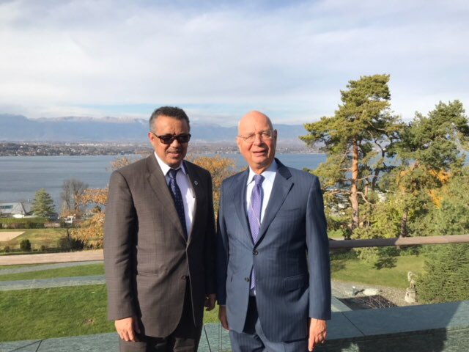
WORLD UNPREPARED FOR ANOTHER PANDEMIC, CAPACITY BUILDING UNDERWAY: WHO CHIEF AT WEF
CAPACITY BUILDING BASED ON LESSONS LEARNED IS UNDERWAY ON A GLOBAL SCALE.
An agreement that will help establish a structure for pandemic prevention, preparedness, and response has been in the works since 2021. ON A GLOBAL LEVEL, GHEBREYESUS SAID THERE WAS AN INCREASE IN INTERGOVERNMENTAL COLLABORATIONS—SURVEILLANCE THROUGH COLLABORATIVE INTELLIGENCE.
The world remains unprepared to tackle another pandemic, the head of the UN health agency said during a summit in Riyadh on Sunday. However, capacity building based on lessons learned is underway on a global scale. Speaking at a WORLD ECONOMIC FORUM (WEF) PANEL IN SAUDI ARABIA, THE WORLD HEALTH ORGANIZATION (WHO) DIRECTOR-GENERAL TEDROS GHEBREYESUS said: “We are unprepared, and we’re still vulnerable to the same problem,” referring to the COVID-19 pandemic of 2020 that brought the world to a standstill.
ON A GLOBAL LEVEL, GHEBREYESUS SAID THERE WAS AN INCREASE IN INTERGOVERNMENTAL COLLABORATIONS—SURVEILLANCE THROUGH COLLABORATIVE INTELLIGENCE, a mechanism to share pathogens for research, aiding countries with capabilities to move into the production of medical goods, and the CREATION OF A PANDEMIC FUND RUN BY THE WORLD BANK. “The key is to have a binding pandemic agreement that member states will respect. So, if anything happens, the best is to prevent it,” the WHO chief said, adding: “And that’s why WE ARE BUILDING CAPACITY.”
Saudi Arabia and the Bill & Melinda Gates Foundation announced they had joined forces to eradicate infectious diseases and to lifting millions more from poverty across 33 Islamic Development Bank (IsDB) member countries.
Advisor to the Royal Court and Supervisor General of the King Salman Humanitarian Aid and Relief Center (KSrelief), Dr Abdullah al-Rabeeah, and Saudi Arabia’s minister of health, Fahad bin Abdurrahman al-Jalajel, announced A FUND EXCEEDING $620 MILLION AT THE RIYADH MEETING IN THE PRESENCE OF THE WHO DIRECTOR-GENERAL AND BILL GATES. Ghebreyesus also noted that the world was off track with the UN Sustainable Development Goals, which are a universal call to action to end poverty, protect the planet, and ‘ENSURE PEACE AND STABILITY’ BY 2030.

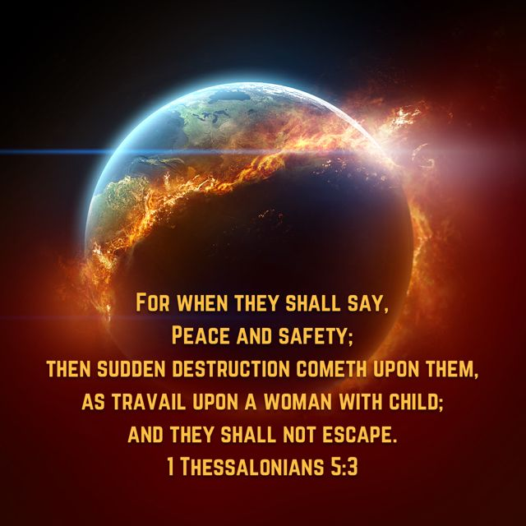
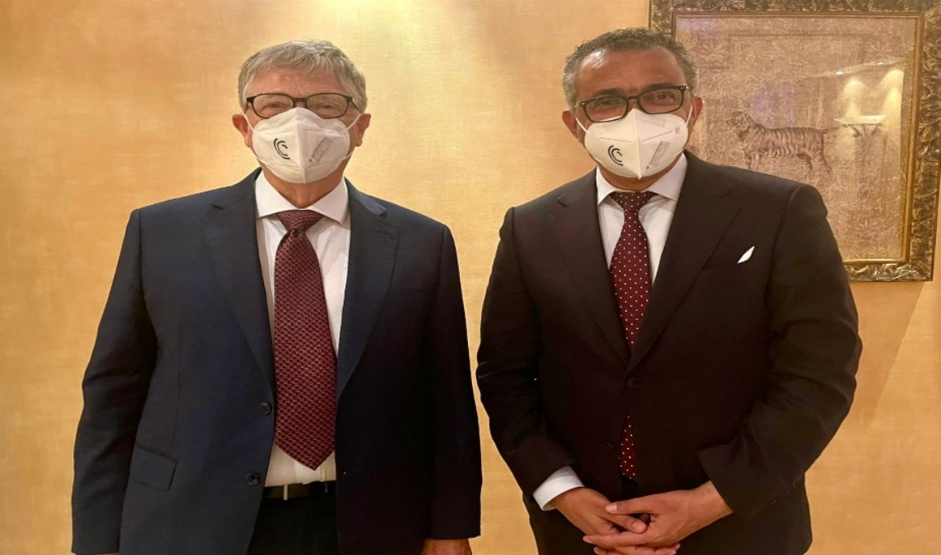

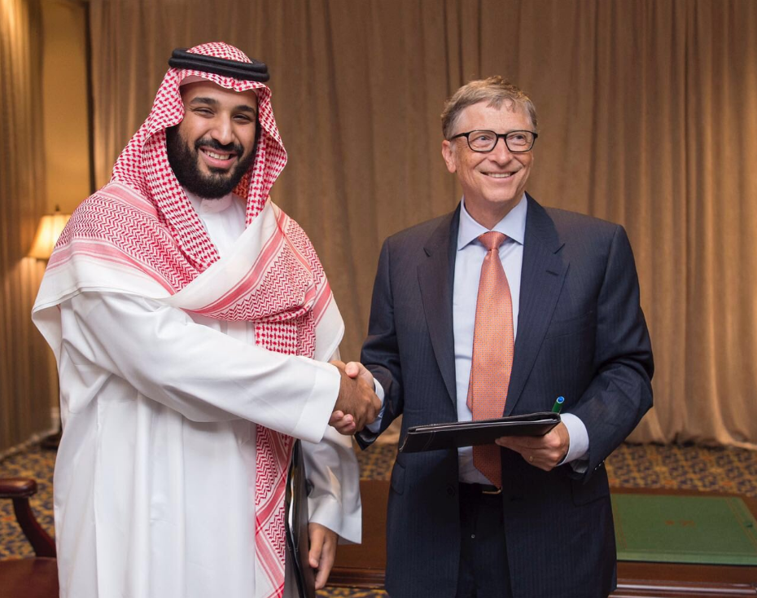
SAUDI ARABIA AND THE BILL & MELINDA GATES FOUNDATION ANNOUNCED SEVERAL COMMITMENTS
$500 MILLION INITIATIVE
SAUDI ARABIA HAS PLEDGED $500 MILLION OVER THE NEXT FIVE YEARS TO THE INITIATIVE, a public-private partnership led by national governments with six (6) partners, including the Bill & Melinda Gates Foundation. This is the largest contribution made by the Kingdom.
REGIONAL OFFICE IN RIYADH
TO SUPPORT THE IMPLEMENTATION OF THE PROGRAMS, THE BILL & MELINDA GATES FOUNDATION WILL ESTABLISH A REGIONAL OFFICE IN RIYADH, IN MOHAMMED BIN SALMAN NONPROFIT CITY, and partner with the MiSK Foundation to support youth engagement.
THE BILL & MELINDA GATES FOUNDATION is also working with SAUDI ARABIA’S MINISTRY OF HEALTH to ensure a safe and healthy Hajj pilgrimage by IMPROVING DISEASE SURVEILLANCE AND TESTING, bringing safe and clean sanitation solutions to millions of Hajj pilgrims, and PROVIDING TECHNICAL ASSISTANCE TO SUPPORT SAUDI ARABIA’S VACCINE MANUFACTURING CAPABILITIES, with the aim of helping low- and middle-income countries access lower-cost vaccines.
“This investment towards global health isn’t just a good to have; it’s a strategic imperative for a thriving, more resilient future together. “The world faces many health challenges, and it is part of our responsibility and leadership to contribute with our partners in bridging the gaps, and through concerted efforts, we will be able to alleviate the suffering of many people.”

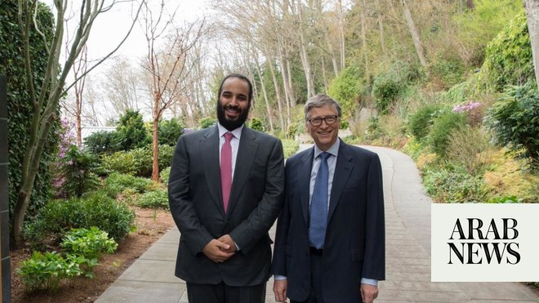
BILL GATES BEHIND “DIGITAL PUBLIC INFRASTRUCTURE” FOR GLOBAL CONTROL
50 GOVERNMENTS EXPECT TO HAVE AN ORWELLIAN “DIGITAL INFRASTRUCTURE” OF TYRANNY IN PLACE WITHIN FIVE (5) YEARS, AND BILL GATES IS WORKING TO GET IT DONE.
DOZENS OF NATIONAL GOVERNMENTS ARE JOINING WITH THE UNITED NATIONS AND BILLIONAIRE POPULATION-CONTROL FANATIC BILL GATES ON A GLOBAL PROGRAM TO IMPOSE “DIGITAL PUBLIC INFRASTRUCTURE” (DPI) ON THEIR CITIZENS WITHIN FIVE YEARS. THIS “DPI” INCLUDES CENTRAL BANK DIGITAL CURRENCIES (CBDCS), DIGITAL IDENTIFICATION, COMPREHENSIVE DATA SYSTEMS, AND MORE, ALL FUNCTIONAL ACROSS NATIONAL BORDERS.
THE NEW SCHEME, UNVEILED LATE LAST YEAR AND MOVING AHEAD RAPIDLY, IS KNOWN AS “50 IN 5” BECAUSE 50 GOVERNMENTS EXPECT TO HAVE THE ORWELLIAN “DIGITAL INFRASTRUCTURE” OF TYRANNY IN PLACE WITHIN FIVE YEARS. Almost a dozen governments, including numerous corrupt kleptocracies and socialist regimes, have volunteered their populations to serve as “First Mover” countries so far. However, the UN’s assumption is that every government will eventually impose this on every person on Earth. This is clearly expressed throughout its announcements. “ALL COUNTRIES, REGARDLESS OF INCOME LEVEL, GEOGRAPHY, OR WHERE THEY ARE IN THEIR DIGITAL TRANSFORMATION JOURNEY, CAN BENEFIT FROM BEING A PART OF 50-IN-5,” THE UN AGENCY BEHIND THE SCHEME DECLARED. “Joining the campaign helps ensure countries don’t have to tackle DPI implementation alone or start from scratch.”
Led by the UN DEVELOPMENT PROGRAMME (UNDP), THE NEW “DIGITAL INFRASTRUCTURE” IS BEING FRAMED AS A TOOL TO ACCELERATE THE IMPOSITION OF THE HIGHLY CONTROVERSIAL UN’S 2030 AGENDA “SUSTAINABLE DEVELOPMENT GOALS,” referred to in 2015 by key UN leaders as the “MASTER PLAN FOR HUMANITY.” The SDGs, as they are known, call for global wealth redistribution and drastically more government power over people’s lives at all levels. The mass-murdering regime ruling China boasted of playing a “crucial role” in developing the plan.
Gates, who had a troubling relationship with convicted child sex trafficker Jeffrey Epstein, celebrated the role of these technologies in imposing the UN SDGs on humanity. “THE G20 REACHED A GROUNDBREAKING CONSENSUS ON THE ROLE OF DIGITAL PUBLIC INFRASTRUCTURE AS A CRITICAL ACCELERATOR OF THE SUSTAINABLE DEVELOPMENT GOALS,” HE SAID ON X. “I’M OPTIMISTIC ABOUT THE POTENTIAL OF DPI TO SUPPORT A SAFER, HEALTHIER, AND MORE JUST WORLD.”
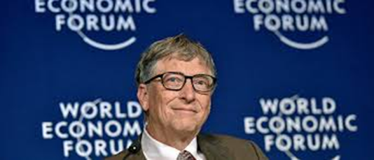
The whole program is being guided by the UN and elitists including Gates and others such as the Rockefellers, longtime financiers of globalism, eugenics, and population-control schemes. Multiple front groups steered by such “controligarchs” were created for the purpose. But U.S. and European taxpayers are being conscripted to foot much of the bill via UN agencies and international “development” banks.
If not stopped, critics say THE NEW SUITE OF “DIGITAL PUBLIC GOODS” AND “INFRASTRUCTURE” WILL CREATE A TECHNOLOGICAL PANOPTICON ALLOWING FOR TOTAL SURVEILLANCE AND CONTROL OF ALL PEOPLE EVERYWHERE. Indeed, as the 2030 VISION AGENDA MAKES CLEAR, “NO ONE WILL BE LEFT BEHIND.” Once in full swing, literally every transaction would be tracked, monitored, and controlled.
UN bureaucrats put a happy face on the program. “For UNDP, a DPI approach that combines people-centric governance is critical to ensure that this new infrastructure can accelerate the [2030 AGENDA] SDGS,” argued Keyzom Ngodup Massally, head of digital programs at UNDP. “THIS COUNTRY-LED 50-IN-5 CAMPAIGN IS A CORE PART OF HOW UNDP CONTINUES TO SUPPORT MEANINGFUL GLOBAL DIGITAL COOPERATION AND STRENGTHENS LOCAL ECOSYSTEMS TO DESIGN AND IMPLEMENT RIGHTS-BASED DPI.”
Already, VIRTUALLY ALL NATIONAL GOVERNMENTS AND CENTRAL BANKS AROUND THE WORLD ARE WORKING ON CENTRAL BANK DIGITAL CURRENCIES (CBDCS), according to the Bank for International Settlements in Switzerland that is helping to guide and COORDINATE THE ROLLING OUT OF SUCH CURRENCIES WORLDWIDE. AS CASH IS SIDELINED AND THEN DISAPPEARS, CBDCS WILL CREATE A PERMANENT RECORD OF ALL TRANSACTIONS.
Perhaps even more troubling, the DIGITAL CURRENCIES WILL ALSO BE PROGRAMMABLE, leading experts and officials say. That will allow governments an UNPRECEDENTED DEGREE OF CONTROL OVER THE ECONOMY AND INDIVIDUAL DECISIONS OF CONSUMERS. In fact, the Biden White House has even called for CBDCs to advance “racial equity” and “environmental priorities.” Leading luminaries have called for them to track individual carbon footprints, too.
ALONG WITH CBDCS, GOVERNMENTS AROUND THE WORLD ARE ROLLING OUT DIGITAL IDS TO GO WITH THEM. The Australian Senate just voted to approve such a system last week. Multiple American state governments, including some controlled entirely by Republicans, are pursuing similar schemes. And various organizations associated with Gates, the Rockefeller dynasty, and the UN have been PROMOTING SUCH IDS FOR YEARS, INCLUDING THROUGH GROUPS SUCH AS ID2020.
Ultimately, the DIGITAL IDS AND CBDCS WILL BECOME INSEPARABLE. The Financial Times discussed the relationship between all the different systems in the digital infrastructure system in a 2021 piece headlined “Why CBDCs Will Likely Be ID-based.” It reveals how CBDCS AND DIGITAL IDS CAN (AND WILL) BE USED TOGETHER TO ULTIMATELY CONTROL PEOPLE. “What CBDC research and experimentation appears to be showing is that it will be nigh on impossible to issue such currencies outside of a comprehensive national digital ID management system,” wrote FT’s Izabella Kaminska. “Meaning: CBDCS WILL LIKELY BE TIED TO PERSONAL ACCOUNTS THAT INCLUDE PERSONAL DATA, CREDIT HISTORY AND OTHER FORMS OF RELEVANT INFORMATION.”
Eventually, HEALTHCARE WILL BECOME INTERTWINED WITH ALL OF IT, as CCP-backed World Health Organization boss (and former ethno-Marxist terrorist leader) Tedros Ghebreyesus explained. “The COVID19 pandemic highlighted the value of digital health solutions in facilitating access to health services,” he declared before touting COVID “vaccine passports” imposed by the European Union. THE WHO IS NOW USING THE EU’S SYSTEM TO DESIGN A SIMILAR REGIME FOR ALL OF HUMANITY.
Top globalists have hinted at where this is all going. “THE TRICK IS TO BUILD PUBLIC DIGITAL INFRASTRUCTURE, THAT IS INTEROPERABLE, OPEN TO ALL AND TRUSTED. Let me give you one example that is reality today,” said EU “President” Ursula von der Leyen at the G20 summit in September. “Many of you are familiar with the COVID-19 digital certificate. The EU developed it for itself. The model was so functional and so trusted that 51 countries on 4 continents adopted it for free.”
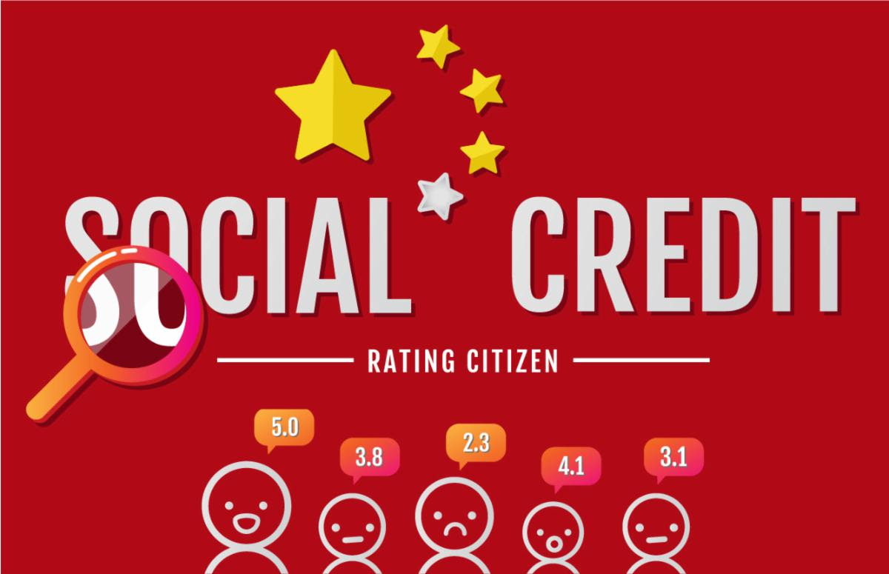
A SOCIAL-CREDIT SCORE WHEREBY EACH INDIVIDUAL RECEIVES A RANK BASED ON HIS OR HER COMPLIANCE WITH TECHNOCRATS’ DEMANDS IS ESSENTIALLY INEVITABLE under this regime as well, critics say. “Advocates are adamant that DPI is essential for participation in markets and society — just like we saw with vaccine passports — only on a much broader scope,” explained The Sociable editor Tim Hinchliffe, one of the first to sound the alarm.
The potential for control, he continued, is almost endless. “If successful, DPI will give governments and corporations the power to implement systems of social credit that can determine where and how you can travel, what you are allowed to consume, and how you will be able to transact with your programmable money,” added Hinchliffe.
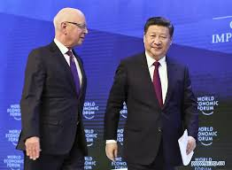
Of course, this sort of system already exists in Communist China, something The New American has been warning about for almost a decade. THE CCP SERVES AS A “ROLE MODEL,” ACCORDING TO WORLD ECONOMIC FORUM BOSS AND GREAT RESET FRONTMAN KLAUS SCHWAB AND COUNTLESS OTHER GLOBALISTS. And so, it is only a matter of time before such a regime is eventually unveiled in the West without massive opposition.
Tracking children is at the top of the priority list, according to the WEF, as the data gathered is used to make decisions for people. “Fundamentally, a digital public infrastructure is about enabling data to flow seamlessly across sectors and systems, thereby enabling data-driven decision-making and policies,” the globalist organization says in a piece about tracking children with DPI.
The “Digital Public Infrastructure” will also fuel increasing restrictions on everyday life, including on movement amid the emergence of 15-minute cities. It will be used to impose all sorts of mandates, including “lockdown” policies under pretexts ranging from alleged “public health” emergencies to supposed man-made “climate change,” opponents are warning, citing statements by the peddlers of these systems.
But it gets weirder. At the end of what Schwab describes as THE “FOURTH INDUSTRIAL REVOLUTION,” THERE WILL BE A “FUSION OF OUR DIGITAL, OUR PHYSICAL, AND OUR BIOLOGICAL IDENTITIES,” the German technocrat has said on multiple occasions. The full implications of that vision have not been worked out, but Schwab himself frequently promotes microchips to be implanted inside of human brains, among other transhumanist schemes.
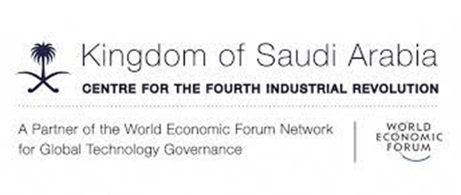
THE “50 IN 5” CAMPAIGN FOR DPI OFFICIALLY LAUNCHED LATE LAST YEAR IN NEW YORK. IT AIMS TO “RADICALLY SHORTEN” THE LENGTH OF TIME THAT IT WOULD TAKE TO DIGITIZE EVERYTHING FROM IDENTIFICATION TO CURRENCY. That will happen through collaboration between the UN and governments as they share technology to eventually create an interoperable system in at least 50 countries by 2028. The whole world is expected to follow suit.
In addition to the UNDP, the Gates Foundation, and the governments that have already signed up, a wide array of AstroTurf groups and UN agencies is also involved — many of them funded by governments as well as profiteers such as Gates and his technocratic allies. These include UNICEF, the Inter-American Development Bank, the Centre for Digital Public Infrastructure, and the Digital Public Goods Alliance.
The first governments to jump on the bandwagon — most with promises of “free” money extracted from Western taxpayers — include Bangladesh, Ethiopia, Guatemala, Moldova, Senegal, Sierra Leone, Sri Lanka, and Togo. A handful of wealthier governments, including those in Norway and Singapore, have also signed on.
“These countries serve as beacons of progress and inspiration for countries to build their own digital foundations and improve their economies and the well-being of people,” claimed the UNDP in a press release announcing the FIRST 11 GOVERNMENTS TO PARTICIPATE IN IMPOSING THESE DIGITAL SURVEILLANCE AND CONTROL TOOLS ON THEIR POPULATIONS.
By bringing 50 governments into the program, the UN is hoping each one can focus on one area or element of the “DPI” scheme. Then, each government will share what it learned with other governments, so the DIGITAL SURVEILLANCE AND CONTROL ARCHITECTURE CAN BE IMPOSED FASTER AND IN A WAY THAT TRANSCENDS NATIONAL BORDERS.
Sierra Leonean Minister of Communication, Technology, and Innovation Salima Monorma Bah called on all governments to sign on. “Sierra Leone is excited to be part of 50-in-5 and urges everyone else to join the campaign — THE NEXT FIVE YEARS ARE THE WINDOW OF OPPORTUNITY TO SPEED UP SAFE AND INCLUSIVE DPI IMPLEMENTATION TOGETHER AND THEREBY ACCELERATE POSITIVE OUTCOMES FOR PEOPLE GLOBALLY,” Bah said.
Even as totalitarian technocrats rush ahead with these technologies, opposition is growing. In Florida, for example, a new law has officially banned CBDCs. Numerous other states are pursuing similar measures. After the devastating lies and tyranny that underpinned the Covid “pandemic” were exposed, billions of people around the world are unlikely to ever have their trust in institutions restored, with most Americans now saying the media is an “enemy.”
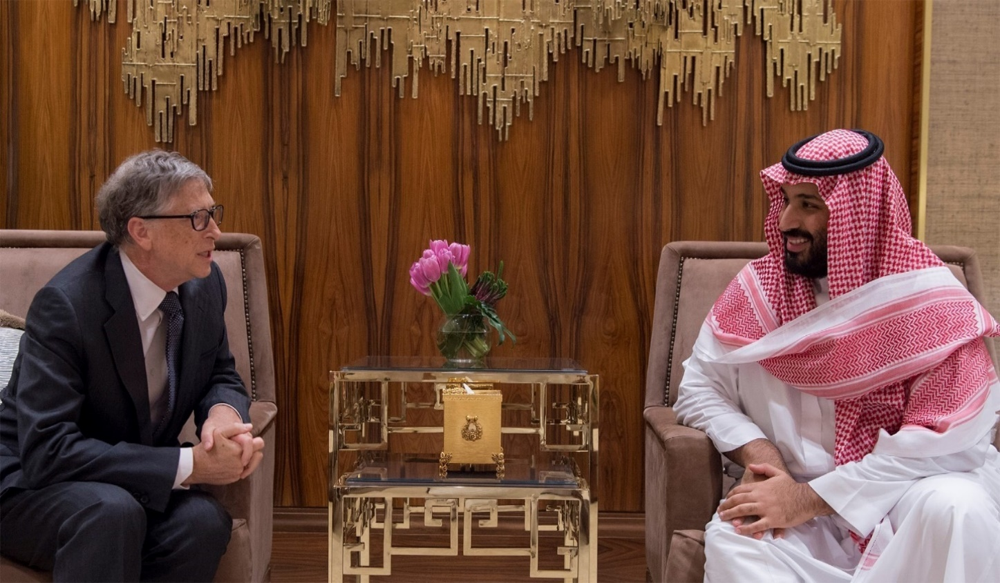

AMIDST GROWING RESISTANCE, THE WHO TURNS UP HEAT ON MEMBERS TO SIGN PANDEMIC TREATY
As the deadline approaches for the 194 member nations of the World Health Organization (WHO) to sign agreements granting broad new powers to this U.N. subsidiary, its ADVOCATES ARE TURNING UP THE HEAT ON MEMBER COUNTRIES TO GET ON BOARD, despite growing resistance to the deal. On March 20, WHO Ambassador and former UK Prime Minister Gordon Brown hailed a campaign by a “100+ PANTHEON OF GLOBAL LEADERS” URGING MEMBER NATIONS TO SIGN.
“A high-powered intervention by 23 former national Presidents, 22 former Prime Ministers, a former UN General Secretary, and 3 Nobel Laureates is being made today TO PRESS FOR AN URGENT AGREEMENT FROM INTERNATIONAL NEGOTIATORS ON A PANDEMIC ACCORD, UNDER THE CONSTITUTION OF THE WORLD HEALTH ORGANIZATION, TO BOLSTER THE WORLD’S COLLECTIVE PREPAREDNESS AND RESPONSE TO FUTURE PANDEMICS,” stated a press release from the office of Gordon and Sarah Brown.
The WHO ambassador also called for worldwide action to “expose fake news disinformation campaigns by conspiracy theorists trying to torpedo international agreement for the Pandemic Accord.” At stake is a new global medical treaty, as well as amendments to existing International Health Regulations (IHRs), which together WOULD MAKE THE WHO THE CENTRAL AUTHORITY DURING PANDEMICS AND OTHER WHO-DECLARED HEALTH CRISES, WHILE SENDING TENS OF BILLIONS OF DOLLARS TO THIS UN SUBSIDIARY. Critics say the WHO has studiously avoided calling the agreement a treaty because treaties typically require approval from national legislatures, and in the case of the United States by two-thirds of the Senate.
What has instead been deemed the Pandemic Agreement or Pandemic Accord, together with amendments to the IHRs, is scheduled to be approved in Geneva, Switzerland, at the World Health Assembly’s annual meeting on May 27–June 1. On March 18, more than 80 ministers and church organizations added their voices to the “pantheon,” telling delegates from member countries that “REACHING AN AGREEMENT THAT ENSURES THAT EVERYONE, EVERYWHERE CAN BENEFIT FROM SCIENTIFIC ADVANCEMENT” WAS A MORAL OBLIGATION.
Tying the signing of WHO agreements to religious calendars, their letter stated that the gathering of WHO delegates “commences as Muslims observe the holy month of Ramadan … when the second week of negotiations begins, Hindus will mark Holi … Christians will be observing lent, and you will conclude on Good Friday … the text of the Pandemic Accord will be finalised during Passover … and the Accord is due to be signed at the World Health Assembly just after Buddhists celebrate Vesak.”
ONE OF THE PRIMARY CONCERNS THAT CRITICS HAVE RAISED IS THAT COUNTRIES WOULD CEDE AUTHORITY TO THE WHO, ONCE THAT ORGANIZATION DECLARES A “HEALTH EMERGENCY.” WHO advocates, however, say such concerns are unfounded and giving voice to them could jeopardize the approval process.
“The accord is being put at risk by a misinformation campaign through social media outlets that is falsely accusing the WHO,” Mr. Brown stated. “No country will cede any sovereignty, and no country will see their national laws set aside,” he stated. “It is time for countries to expose fake news disinformation campaign by conspiracy theorists to torpedo a much-needed accord.”
In line with that view, the Associated Press (AP) issued a “fact check” in February 2023, declaring that the idea that member nations would lose sovereignty was “false.” The AP cited the U.S. Department of Health and Human Services (HHS), which is currently negotiating the agreement on America’s behalf, which stated: “It is false to claim that the World Health Organization has now, or will have by virtue of these activities, any authority to direct U.S. health policy or national health emergency response actions.”
The AP also cited a refutation from Georgetown University law professor Lawrence Gostin, who helped draft the treaty as director of the university’s WHO Collaborating Center on National and Global Health Law. Mr. Gostin told the AP that the treaty uses terms like “should,” indicating suggestions, rather than “must,” to underscore that the WHO remains a consultative rather than an authoritative body.
However, THE LANGUAGE IN THE MARCH 13 DRAFT OF THE TREATY APPEARS TO BE COMPULSORY, STATING THROUGHOUT THE DOCUMENT THAT “THE PARTIES COMMIT TO …” AND “THE PARTIES SHALL …” WITH THE WORD “SHALL” USED MORE THAN 160 TIMES.
https://www.ganjingworld.com/s/ezBpzNG3KO
In addition, THE IHR AMENDMENTS STATE THAT MEMBER STATES “RECOGNIZE WHO AS THE GUIDANCE AND COORDINATING AUTHORITY OF INTERNATIONAL PUBLIC HEALTH RESPONSE DURING A PUBLIC HEALTH EMERGENCY OF INTERNATIONAL CONCERN AND UNDERTAKE TO FOLLOW WHO’S RECOMMENDATIONS IN THEIR INTERNATIONAL PUBLIC HEALTH RESPONSE.”
Other areas of concern regarding sovereignty include a directive that “health measures” stipulated by the WHO “shall be initiated and completed without delay by all Parties” and that “State Parties shall also take measures to ensure Non-State-Actors operating in their respective territories comply with such measures.” In addition, references to the documents being “non-binding” on member states were removed.
“They are trying to make out that this is some mild feel-good agreement that won’t really affect anyone and therefore doesn’t need to go to national legislatures,” Dr. David Bell a public health physician who formerly worked with the WHO on infectious disease diagnostics, told The Epoch Times. Dr. Bell has been tracking the progress of the agreements with a critical eye. Supporters of the agreements have also asserted that, regardless of what the documents say, the treaty and IHR amendments are toothless because the WHO will have no authority to enforce any of its directives or recommendations, and cannot force lockdowns or quarantines on member nations.
However, a 2022 petition signed by 15 state attorneys general argues that the HHS could have such authority once the WHO declares a health emergency. The state AGs wrote in protest of an HHS decision on Jan. 19, 2017, “one day before President [Barack] Obama’s second term expired,” to give the Director-General of the WHO the authority to declare a public health emergency within the United States.
“ALLOWING AN INTERNATIONAL ORGANIZATION TO DETERMINE WHEN PUBLIC HEALTH EMERGENCIES EXIST IN THE UNITED STATES NECESSARILY ALLOWS THAT ORGANIZATION TO USE POLICE POWERS THAT WERE NEITHER GIVEN TO IT OR TO THE FEDERAL GOVERNMENT BY THE STATES,” THE AGS STATED, CALLING IT “AN EXTREME VIOLATION OF BOTH STATE AND FEDERAL SOVEREIGNTY.”
During a health emergency, the state AGs wrote, “HHS may provide for the apprehension and examination of individuals in certain infected states. Upon recommendation of the HHS Secretary, the President of the United States may also authorize the detention of individuals under certain circumstances.”
Another concern, critics say, is that the process of signing over new powers to the WHO has been needlessly rushed and avoids the public discussions and debates that should be part of the process when countries enter into treaties. According to a report by a research group at the University of Leeds in the UK, co-authored by Dr. Bell, “Pandemic risk is characterized as an ‘existential threat to humanity’ and is being used to justify proposed amendments to the International Health Regulations and a new legally binding Pandemic Agreement.”
But the report argues that, based on the WHO’s own data, the evidence does not support the urgent need for, or the benefits of, giving more power to the WHO. What the WHO claims is an escalating frequency of pandemics can be largely explained by improved diagnostic testing in recent decades, the authors say, nor is the proposed remedy of centralizing pandemic response within the WHO justified by objective facts.
“They require countries to comply because they’re saying that, during COVID countries didn’t act fast enough, and therefore they have to be told what to do,” Dr. Bell said. But the WHO has not explained how, if it had the authority it is now seeking, it would have saved more lives. “The whole narrative that they need this at all is not supported by any evidence that they put forward,” he said. Many policy analysts have argued that the WHO’s actions during COVID-19 did little to help the public and may have even exacerbated the crisis.
“The WHO should have played an important role in sharing information with member nations during a global pandemic, but instead it demonstrated that it could not and would not share information in a timely and accurate manner,” the state AGs wrote in their petition. “Instead of reporting public health information, the WHO chose to repeat Chinese propaganda regarding COVID.”
The WHO agreements also require that billions of dollars be paid to the WHO by member nations to enable it to carry out its new duties. “This agenda is supported by unprecedented annual financial requests,” the Leeds University report states, including $36 billion in new member contributions and an additional $10 billion for what the WHO calls “One Health” interventions.
ONE HEALTH, AS DEFINED IN THE PANDEMIC AGREEMENT, IS “AN INTEGRATED, UNIFYING APPROACH THAT AIMS TO SUSTAINABLY BALANCE AND OPTIMIZE THE HEALTH OF PEOPLE, ANIMALS, AND ECOSYSTEMS.” A ONE HEALTH APPROACH COULD EFFECTIVELY EXPAND THE AUTHORITY OF HEALTH OFFICIALS INTO AREAS SUCH AS FARMING, POLLUTION, AND CLIMATE CHANGE.
The WHO constitution “is very specific about what kinds of regulations the WHO can issue, and they’re limited,” Dr. Nass told The Epoch Times. “What has been put into the [IHR] amendments goes way beyond what they’re allowed to issue as regulations and would need to be issued as a treaty.”

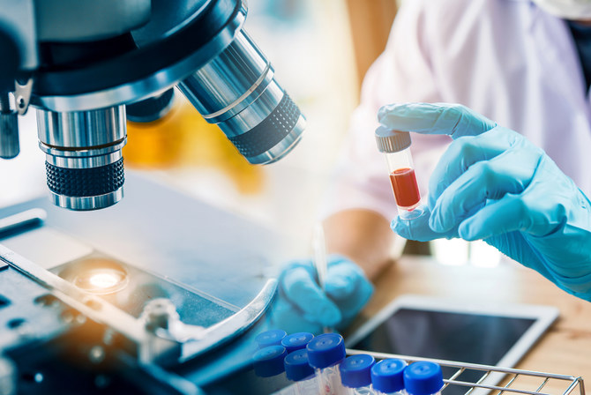
SAUDI ARABIA LAUNCHES NATIONAL BIOTECHNOLOGY STRATEGY TO LEAD GLOBAL INNOVATION
RIYADH: LOCALIZING VACCINE MANUFACTURING and improving the health of Saudi citizens are among the KEY GOALS OF A NEW NATIONAL BIOTECHNOLOGY STRATEGY, LAUNCHED BY CROWN PRINCE MOHAMMED BIN SALMAN. ONE OF THE MAJOR FOCUSES OF THE INITIATIVE IS LOCALIZING VACCINE MANUFACTURING TO INCREASE THE KINGDOM’S SELF-SUFFICIENCY AND ENSURE TIMELY ACCESS TO THESE MEDICINES FOR ITS CITIZENS.
Furthermore, the program targets a 3 percent contribution of the biotechnology sector to the non-oil gross domestic product by 2040, with a cumulative impact of SR130 billion ($34.66 billion), in addition to providing thousands of high-quality opportunities and jobs.
THESE INITIATIVES ARE ALIGNED WITH THE KINGDOM’S VISION 2030.
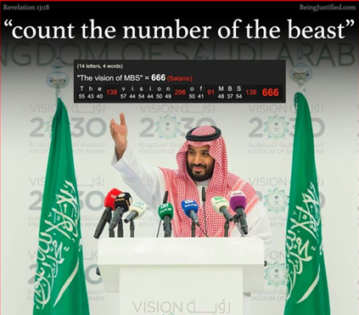
“LOCALIZATION AND BIOMANUFACTURING PLAY A VITAL ROLE IN DRIVING THE STRATEGY FORWARD, AS SAUDI ARABIA AIMS TO ESTABLISH ITSELF AS THE PRIMARY BIOTECHNOLOGY HUB IN THE MENA (MIDDLE EAST AND NORTH AFRICA) REGION.” “DEVELOPING ADVANCED BIOPHARMA MANUFACTURING CAPABILITIES AND ESTABLISHING A CUTTING-EDGE LOCAL END-TO-END BIO-MANUFACTURING PLATFORM ARE CRUCIAL STEPS.” THE PROGRAM FOCUSES ON FOUR STRATEGIC DIRECTIONS, INCLUDING VACCINES, WITH AN EMPHASIS ON LOCALIZING VACCINE PRODUCTION, EXPORTING, AND LEADING INNOVATION IN THE FIELD.
Additionally, it prioritizes biomanufacturing, aiming to increase the consumption and localization of biopharmaceuticals. THE STRATEGY ALSO HIGHLIGHTS GENOMICS, WITH A FOCUS ON PIONEERING RESEARCH AND GENE THERAPY. THE KINGDOM, BEING THE LARGEST REGIONAL MARKET FOR PHARMACEUTICALS AND VACCINES, HAS STRATEGICALLY INVESTED IN BIOTECHNOLOGY-RELATED SECTORS. It is committed to developing and training national talent in research, development, and innovation while enabling a competitive and digital infrastructure.
The country’s genetic diversity and geographical climate provide ideal conditions for conducting complex studies and research. The strategy aims to empower the local biotechnology industry by streamlining regulatory requirements, providing suitable infrastructure, and offering financing. Through its various programs and initiatives, it seeks to stimulate efforts by private sector investors in this field. The launch of this national scheme aims to provide a flexible regulatory environment and advanced infrastructure, fostering integration between the public and private sectors.


SAUDI ARABIA TO BECOME A GLOBAL LEADER IN BIOTECHNOLOGY & STRATEGY
RIYADH: SAUDI ARABIA HAS INVESTED $4 BILLION IN RESEARCH AND DEVELOPMENT SINCE 2021 AND ESTABLISHED INNOVATIVE BIOTECH CLUSTERS IN ITS BID TO BECOME A GLOBAL RESEARCH LEADER, revealed an industry report. According to Strategy& Middle East, part of the PwC network, THE KINGDOM’S VISION 2030 of economic diversification has enabled it to become an international hub for the biotech industry and pharmaceutical manufacturing sector.
Flagship institutions, such as the King Abdullah University of Science and Technology and the King Faisal Specialist Hospital & Research Centre, have made extensive investments in infrastructure.
Advanced labs and innovation initiatives like the SAUDI HUMAN GENOME PROGRAM and the Saudi Network for Clinical Trials are also helping clinician-researchers and commercializing potential technologies. Similarly, THE NATIONAL BIOTECHNOLOGY STRATEGY HAS HELPED STREAMLINE THE KINGDOM’S REGULATORY FRAMEWORK FOR TRIALS, TESTING AND BIOETHICS.
“Biotechnologies, with their ability to develop groundbreaking technologies and medical products, can revolutionize not just the national non-oil economy but everything from the chemicals industry to agriculture, food security and human health,” said Walid Tohme, partner with Strategy& Middle East, in the report.
Claudia Palme, a senior executive advisor with Strategy& Middle East, said that the next step on the value curve involved establishing a more nuanced, targeted approach that brings government and private sector stakeholders together with shared objectives and strong investment incentives. The report also added that increasing public and private funding, expanding human capital, developing a robust infrastructure and creating a solid regulatory framework could ELEVATE THE DOMESTIC BIOTECHNOLOGY SECTOR TO A GLOBAL STAGE.
“Furthermore, a nationwide ecosystem of biotech infrastructures from NEOM BABYLON to KAUST and clusters in Riyadh will yield a successful sector that creates economic diversification, skilled jobs, and many health, social and economic benefits,” said Irfan Merali, a principal with Strategy& Middle East.


SAUDI BIOTECHNOLOGY HELPS DETERMINE LONGEVITY
RIYADH: Many people are unaware that GENETICS plays a role in both quality of life and longevity and this can be improved by diet and surroundings. Budoor Al-Mansour, chief operating officer and co-founder of Novo Genomics, said that biotech aids the client in UNDERSTANDING THEIR GENES AND HOW TO STRENGTHEN THEM TO PREVENT SICKNESSES, LIVE LONGER, AND EVEN SLOW DOWN THE AGING PROCESS. “With the USE OF BIOTECHNOLOGY, WE CAN CREATE A COMPLETE PROFILE OF THE INDIVIDUAL AND PROVIDE SUGGESTIONS DEPENDING ON THEIR UNIQUE NEEDS.
“Biotechnology helped in figuring out what are the things that would help with quality of life and longevity. There is META-GENETIC SCIENCE that reveals that our surroundings may reflect on our GENES TO PROLONG LIFE and stimulate skin cells, such as a green smoothie, which is a drink that not only works on enzymes, but WORKS ON THE EXPRESSION OF GENES improving skin complexion,” she said.
At the lab, customers can drop off a blood sample, which will PROVIDE THEM WITH ALL THE INFORMATION THEY NEED ABOUT THEIR DNA, INCLUDING THE HEREDITARY CAUSES OF SICKNESS OR DISEASE CARRIERS, AND EVEN HELP EXPECTANT MOTHERS FROM HAVING SICK OR DEFORMED CHILDREN.
One of the earliest biotech firms in the Kingdom, Novo Genomics, has been operating for a year with a mission to RAISE AWARENESS OF GENOMICS AND IMPROVE PUBLIC HEALTH. “Due to the lack of biotech labs in the area and the need for patients to send samples to Germany, India or other nations, which raises concerns about national security, we chose to open this clinic in Saudi Arabia to save our data here. Additionally, THE KINGDOM HAS A HIGH RATE OF GENETIC DISEASES — 30 percent of the population — and we are here to HELP FAMILIES IDENTIFY WHAT THEY HAVE AND PREVENT FUTURE MUTATIONS,” Al-Mansour said.
Biotech, biopharma and biomedical are a part of SAUDI ARABIA’S VISION 2030. The Kingdom is keen on increasing AWARENESS ABOUT GENETIC STUDIES AND QUALITY OF LIFE RELATED TO IT. “Instead of relying on people from other countries who might not understand our culture, WE WORKED WITH THE AIM OF EXTENDING HEALTHY LIFESPAN for the benefit of all humanity.

In His Service,
Night Watchman
Paul Rolland
Night Watchman
www.nightwatchman.blog
https://nightwatchmanministries.substack.com/
Make Your (7) Decision for Christ NOW!!!!!!! Time is Up!!!!!!!
Jesus Christ’s Offer of Salvation:
https://youtu.be/4lzupUaqVM0
The ABCs (7) of Salvation through Jesus Christ (the Lamb)
- (7) Admit/Acknowledge/Accept that you are sinner. Ask (7) God’s forgiveness and repent of your sins.
. . . “For all have sinned, and come short of the glory of God.” (Romans 3:23).
. . . “As it is written, There is none righteous, no, not one.” (Romans 3:10).
. . . “If we say that we have no sin, we deceive ourselves, and the truth is not in us.” (1 John 1:8).
B. Believe Jesus is Lord. Believe that (7) Jesus Christ is who He claimed to (7) be; that He was both fully God (7) and fully man and that we are (7) saved through His death, burial, and resurrection. (7) Put your trust in Him as your (7) only hope of salvation. Become a son (7) or daughter of God by receiving Christ. (7777777) 7x7
. . . “That whosoever believeth in him should not perish, but have eternal life. For God so loved the world, that he gave his only begotten Son, that whosoever believeth in him should not perish, but have everlasting life. For God sent not his son into the world to condemn the world; but that the world through him might be saved. (John 3:15-17). For whosoever shall call upon the name of the Lord shall be saved.” (Romans 10:13).
C. Call upon His name, Confess (7) with your heart and with your lips (7) that Jesus is your Lord and Savior.
. . . “That if thou shalt confess with thy mouth the Lord Jesus, and shalt believe in thine heart that God hath raised him from the dead, thou shalt be saved. For with the heart man believeth unto righteousness; and with the mouth confession is made unto salvation.” (Romans 10:9-10).
. . . “If we say that we have no sin, we deceive ourselves, and the truth is not in us. If we confess our sins, he is faithful and just to forgive us our sins, and to cleanse us from all unrighteousness. If we say that we have not sinned, we make him a liar, and his word is not in us.” (John 1:8-10).

